Q501. You are building an application using a virtual machine in Azure. As a security requirement, it is necessary to apply Azure Multi-Factor Authentication (MFA) based on certain conditions.

Which Azure service should you choose?

1. Azure Monitor
2. Azure Advanced Threat Protection (ATP)
3. **Azure Active Directory (Microsoft Entra ID) ID Protection**
4. Azure Security Centre (Microsoft Defender for Cloud)

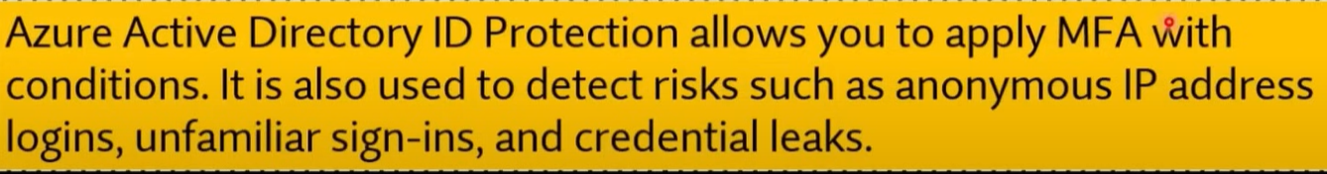

Q502. Your company has virtual machines (VMS) hosted in Microsoft Azure. The VMS are located in a single Azure virtual network named VNet1. The company has users that work remotely. The remote workers require access to the VMS on VNet1. You need to provide access for the remote workers.

1. Configure a Site-to-Site (S2S) VPN.
2. Configure a VNet-toVNet VPN.
3. **Configure a Point-to-Site (P2S) VPN.**
4. Configure DirectAccess on a Windows Server 2012 server VM.
5. Configure a Multi-Site VPN.

Q503. Which of the following provides a command platform for deploying objects to your Cloud infrastructure and maintaining consistency throughout your Azure environment.

1. Azure policy
2. Resource group
3. **Azure resource manager**
4. Management group

**Explanation:**

**Azure Resource Manager (ARM)** is the service in Azure that provides a command platform for deploying, managing, and organizing resources in your Azure environment. It enables you to maintain consistency throughout your infrastructure by using templates (ARM templates) to define and automate resource deployment. ARM ensures that resources are deployed in a consistent manner and supports applying permissions, policies, and tags to resources.

**Other Options:**

* **a. Azure Policy**: Azure Policy helps enforce organizational standards and compliance but does not directly handle resource deployment.
* **b. Resource Group**: Resource groups are containers used to organize and manage related Azure resources but do not provide the deployment platform.
* **d. Management Group**: Management groups help organize and apply policies across multiple subscriptions, but they do not directly handle deployment or resource consistency.

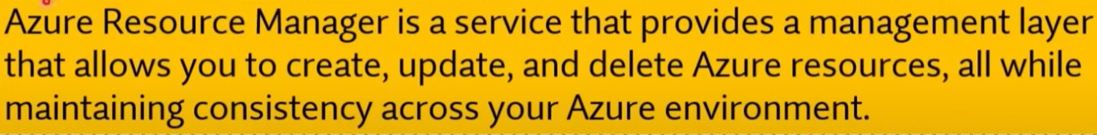

Q504. Your company is planning to move from an on-premises environment to Azure and you have decided to develop your application using Docker as the development environment.

Which of the following is the best service to use for this scenario?

1. Azure App Services
2. **Azure Container Instances**
3. Azure Functions
4. Azure virtual machine

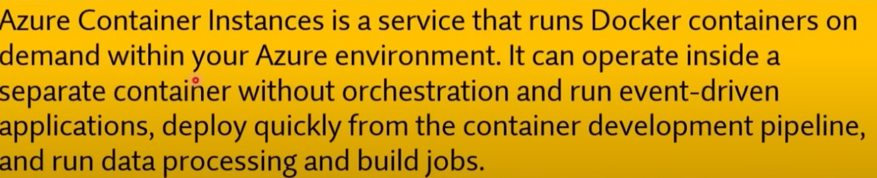

Q505. Which statement accurately describes the Modern Lifecycle Policy for Azure services?

1. Microsoft provides mainstream support for a service for five years.
2. **Microsoft provides a minimum of 12 months' notice before ending support for a service.**
3. After a service is made generally available, Microsoft provides support for the service for a minimum of four years.
4. When a service is retired, you can purchase extended support for the service for up to five years.

Q506. Azure Site Recovery provides fault tolerance for virtual machines.

1. Yes
2. **No**



Q507. Your developers have created a portal web app for users in the Miami branch office. The web app will be publicly accessible and used by the Miami users to retrieve customer and product information. The web app is currently running in an on-premises test environment.

You plan to host the web app on Azure.

You need to determine which Azure web tier plan to host the web app. The web tier plan must meet the following requirements:

* The website will use the miami.weyland.com URL.
* The website will be deployed to two instances.
* SSL support must be included.
* The website requires 12 GB of storage.
* Costs must be minimized.

Which web tier plan should you use?

1. **Standard**
2. Basic
3. Free
4. Shared

* <https://azure.microsoft.com/en-us/pricing/details/app-service/windows/>

Q508. Your developers have created 10 web applications that must be host on Azure.

You need to determine which Azure web tier plan to host the web apps. The web tier plan must meet the following requirements:

* The web apps will use custom domains.
* The web apps each require 10 GB of storage.
* The web apps must each run-in dedicated compute instances.
* Load balancing between instances must be included.
* Costs must be minimized.

Which web tier plan should you use?

1. Standard
2. **Premium**
3. Basic
4. Free
5. Shared

Q509. You are required to deploy an Artificial Intelligence (Al) solution in Azure. You want to make sure that you are able to build, test, and deploy predictive analytics for the solution.

**Solution: You should make use of Azure COSMOS DB.**

Does the solution meet the goal?

1. Yes
2. **No**

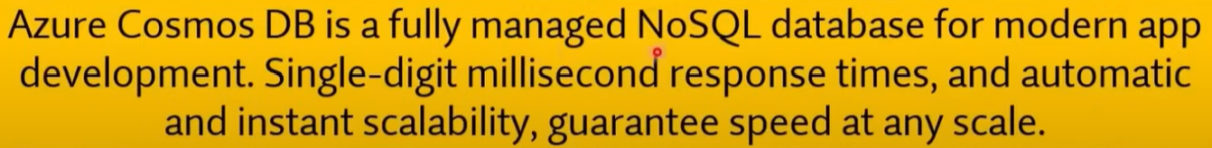

Q510. You are required to deploy an Artificial Intelligence (Al) solution in Azure. You want to make sure that you are able to build, test, and deploy predictive analytics for the solution.

**Solution: You should make use of Azure Machine Learning Studio.**

Does the solution meet the goal?

1. **Yes**
2. No

Q511. Your company's Active Directory Forest includes thousands of user accounts. You have been informed that all network resources will be migrated to Azure. Thereafter, the on-premises data centre will be retired. You are required to employ a strategy that reduces the effect on users, once the planned migration has been completed.

**Solution: You plan to sync all the Active Directory user accounts to Azure Active Directory (Azure AD) (Microsoft Entra ID).**

Does the solution meet the goal?

1. **Yes**
2. No

Q512. What does a customer provide in a software as a service (SaaS) model?

1. **application data**
2. data storage
3. compute resources
4. application software

Q513. What is the first stage in the Microsoft Cloud Adoption Framework for Azure?

1. Adopt the cloud.
2. Make a plan.
3. Ready your organization.
4. **Define your strategy.**

* <https://learn.microsoft.com/en-us/azure/cloud-adoption-framework/overview>

Q514. To which cloud models can you deploy physical servers?

1. public cloud
2. private cloud, hybrid cloud and public cloud
3. hybrid cloud only
4. **private cloud and hybrid cloud**

Q515. Your team needs to have a tool that can be used to process data from millions of sensors. Which of the following service can be used for this purpose?

1. Azure Machine Learning.
2. **Azure IOT Hub.**
3. Azure Al bot.
4. Azure Functions.

Q516. Your team needs a tool that can be used to correlate events from multiple resources into a central repository. Which of the following can be used for this purpose?

1. Azure Event Hubs.
2. Azure Security Centre (Microsoft Defender for Cloud).
3. Azure AD (Microsoft Entra ID).
4. **Azure Log Analytics.**

**Explanation:**

**Azure Log Analytics**, part of **Azure Monitor**, is a service used to collect and analyse data from multiple resources across your Azure environment. It provides a central repository for logs, metrics, and events, allowing you to correlate data from various sources such as virtual machines, applications, network devices, and more. This data can then be queried and visualized to identify trends, troubleshoot issues, and ensure the health and performance of your environment.

**Other Options:**

* **a. Azure Event Hubs**: This is a data streaming service used to capture and process large volumes of events in real time, but it is not specifically designed for log correlation from multiple resources.
* **b. Azure Security Centre (Microsoft Defender for Cloud)**: This service provides security recommendations and insights but is not used for centralizing event logs across resources.
* **c. Azure AD (Microsoft Entra ID)**: Azure AD (Entra ID) is primarily for identity and access management and does not handle centralized event log management.

Q517. A Platform as a Service (PaaS) solution provides full control of operating systems that host applications.

1. Yes
2. **No**

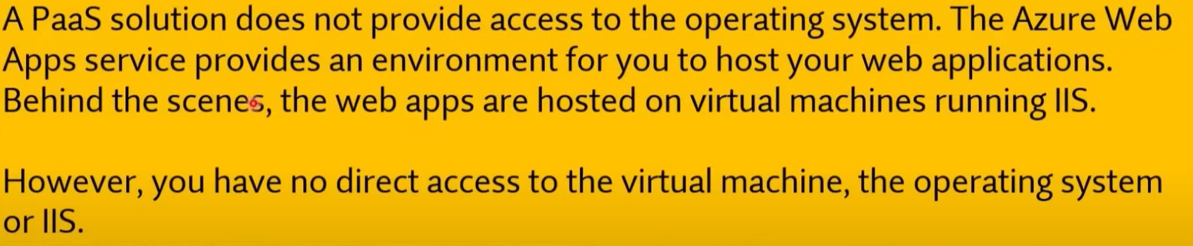

Q518. A Platform as a Service (PaaS) solution provides additional memory to apps by changing pricing tiers.

1. Yes
2. **No**

Q519. A solution that hosts web apps in Azure can be provided with additional memory by changing the pricing tier.

1. **Yes**
2. No

Q520. A Platform as a Service (PaaS) solution can automatically scale the number of instances.

1. **Yes**
2. No

**Explanation:**

**Platform as a Service (PaaS)** solutions in Azure, such as **Azure App Service**, **Azure Functions**, or **Azure SQL Database**, typically include features like **automatic scaling**. This allows the platform to automatically adjust the number of instances (virtual machines or other resources) based on demand. This helps to ensure that applications can handle varying loads without manual intervention, optimizing both performance and cost.

Q521. You can improve composite SLA by adding redundant service to your application

1. **Yes**
2. No

Q522. SLA is a formal agreement between Microsoft and a customer. Which of the following aspects are outlined by the SLA agreement?

1. Scalability
2. Elasticity
3. Fault Tolerance
4. **Availability**

Q523. You have an Azure application that uses the services shown in the following table.

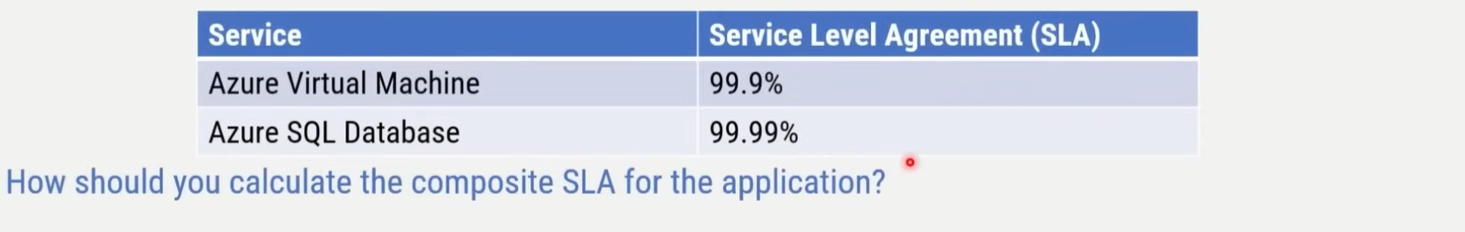

1. 0.999 / 0.9999 = 0.9991 = 99.91%
2. Max(O.999, 0.9999) = 0.9999 99.99%
3. **0.999*0.9999 = 0.9989001 = 99.89001%**
4. Min(O.999, 0.9999) = 0.999 99.9%

* <https://learn.microsoft.com/en-us/azure/well-architected/reliability/metrics#understand-service-level-agreements>

Q524. Adding more dependent services to application improve the composite SLA.

1. Yes
2. **No**

Q525. Adding redundant services to application improves the composite SLA.

1. **Yes**
2. No

Q526. The service configuration can impact on the SLA that Microsoft provides.

1. **Yes**
2. No



Q527. What's the SLA for Azure Maps in terms of guaranteed uptime?

1. 99 percent
2. **99.9 percent**
3. 99.99 percent

Q528. Azure services in public preview are subject to a Service Level Agreement (SLA).

1. Yes
2. **No**



Q529. Companies can increase the Service Level Agreement (SLA) guaranteed uptime by adding Azure resources to multiple regions.

1. **Yes**
2. No



Q530. The Service Level Agreement (SLA) guaranteed uptime for paid Azure services is at least 99.9 percent.

1. **Yes**
2. No



Q531. Companies can increase the Service Level Agreement (SLA) guaranteed uptime by purchasing multiple subscriptions.

1. Yes
2. **No**

Q532. Adding a third virtual machine reduces the composite SLA. How can companies offset this reduction?

1. Increase the size of each virtual machine.
2. **Deploy extra instances of the same virtual machines across the different availability zones in the same Azure region.**
3. Do nothing. Using Azure Load Balancer increases the SLA for virtual machines.

Q533. A Standard support plan is included in an Azure free account.

1. Yes
2. **No**

* Basic support plan.

Q534. Which Service Level Agreement (SLA) is provided for Azure services in public preview?

1. **Each service defines its own SLA**
2. The SLA will be 99%
3. The SLA will be 1% less than the general availability (GA) SLA
4. The SLA will be 99.95%

Q535. A Premier support plan can only be purchased by companies that have an Enterprise Agreement.

1. **Yes**
2. No

* <https://azure.microsoft.com/en-us/pricing/offers/enterprise-agreement-support>

Q536. All Azure services in private preview must be accessed by using a separate Azure portal.

1. Yes
2. **No**

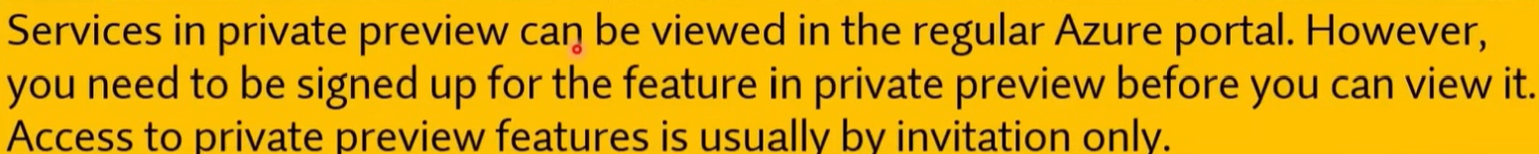

Q537. Azure services in public preview can be used in production environments.

1. **Yes**
2. No



Q538. If your company uses an Azure free account, you will only be able to use a subset of Azure services.

1. Yes
2. **No**



Q539. You can create up to 10 Azure free accounts by using the same Microsoft account.

1. Yes
2. **No**



Q540. All Azure free accounts expire after a specific period.

1. **Yes**
2. No



Q541. Which of the following Azure services provides a set of tools for monitoring, allocating, and optimizing your Azure costs?

1. **Azure Cost Management**
2. Azure Pricing Calculator
3. Total Cost of Ownership Calculator

Q542. Azure Cost Management is a paid service.

1. Yes
2. **No**

Q543. Select the key features of Azure Cost Management.

1. Cost reduction
2. **Cost and Billing information**
3. **Budgets**
4. Cost distribution among resources
5. **Alerts**
6. **Automated Exports**
7. Discounts
8. **Cost recommendations**

* <https://azure.microsoft.com/en-us/products/cost-management>

Q544. Which of the following Azure service allows customer to compare the cost of their on-premises workloads with the same workloads running in Azure platform

1. Azure Cost Management
2. Azure Pricing Calculator
3. **Total Cost of Ownership Calculator**

* <https://azure.microsoft.com/en-us/pricing/tco/calculator/>

Q545. Azure Pricing calculator allows customers to review and estimate the cost of running their Azure services before making a purchase.

1. **Yes**
2. No

Q546. You can use Azure Cost Management to view costs associated with management groups.

1. **Yes**
2. No

* <https://learn.microsoft.com/en-us/azure/cost-management-billing/cost-management-billing-overview#understand-cost-management>

Q547. You can use Azure Cost Management to view costs associated with resource groups.

1. **Yes**
2. No

Q548. You can use Azure Cost Management to view the usage of virtual machines during the last three months.

1. **Yes**
2. No

Q549. Which task can you perform by using Azure Advisor?

1. Integrate Active Directory and Azure Active Directory (Azure AD) (Microsoft Entra ID).
2. Estimate the costs of an Azure solution.
3. **Confirm that Azure subscription security follows best practices.**
4. Evaluate which on-premises resources can be migrated to Azure.

* <https://learn.microsoft.com/en-us/azure/advisor/advisor-overview>

Q550. Your company has 10 offices. You plan to generate several billing reports from the Azure portal. Each report will contain the Azure resource utilization of each office.

Which Azure Resource Manager feature should you use before you generate the reports?

1. **tags**
2. templates
3. locks
4. policies

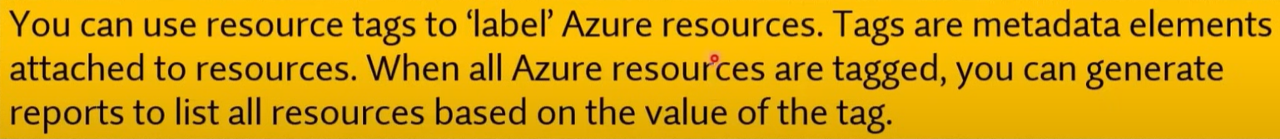

Q551. You deploy an Azure resource. The resource becomes unavailable for an extended period due to a service outage. Microsoft will _______ ?

1. refund your bank account.
2. migrate the resource to another subscription.
3. **credit your Azure account.**
4. send you a coupon code that you can redeem for Azure credits.



Q552. Your team needs to have a tool that provides a digital online assistant for speech support. Which of the following services can be used for this purpose?

1. Azure Machine Learning
2. Azure IOT Hub
3. **Azure Al bot**
4. Azure Functions

Q553. A single Microsoft account can be used to maintain multiple azure subscriptions.

1. **Yes**
2. No



Q554. A company can store resources in multiple subscriptions.

1. **Yes**
2. No



Q555. Two Azure subscriptions can be merged into a single subscription by creating a support request.

1. Yes
2. **No**

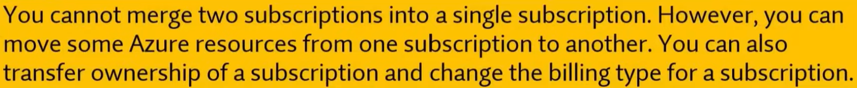

Q556. Each Azure subscription can contain multiple account administrators.

1. Yes
2. **No**



Q557. Each Azure subscription can be managed by using a Microsoft account only.

1. Yes
2. **No**

**Explanation:**

Azure subscriptions can be managed using both **Microsoft accounts (personal accounts)** and **Azure Active Directory (Azure AD) (Microsoft Entra ID) accounts (work or school accounts)**. Azure AD accounts are typically used in organizational settings to manage access to Azure resources. This allows organizations to control and secure access to resources through Azure AD, where administrators can assign roles and manage permissions.

While Microsoft accounts (e.g., Outlook.com or Hotmail.com) can be used to create and manage subscriptions, **Azure AD (Microsoft Entra ID) accounts are more commonly used in corporate environments** for managing Azure subscriptions securely.

Q558. An Azure resource group contains multiple Azure subscriptions.

1. Yes
2. **No**



Q559. Your team needs to have a tool that can use past training to provide predictions of very high probability. Which of the following services can be used for this purpose?

1. **Azure Machine Learning.**
2. Azure IOT Hub.
3. Azure Al bot.
4. Azure Functions.

Q560. If you plan to host web application in the Azure platform as a service solution of Azure Web Apps, then the platform will have the ability to scale automatically?

1. **Yes**
2. No

Q561. Your company plans to deploy several web servers and several database servers to Azure. You need to recommend an Azure solution to limit the types of connections from the web servers to the database servers.

What should you include in the recommendation?

1. **network security groups (NSGs)**
2. Azure Service Bus
3. a local network gateway
4. a route filter

Q562. You have an Azure Sentinel workspace. You need to automate responses to threats detected by Azure Sentinel. What should you use?

1. Adaptive network hardening in Azure Security Center
2. Azure Service Health
3. **Azure Monitor workbooks**
4. Adaptive application controls in Azure Security Center

* <https://learn.microsoft.com/en-us/azure/sentinel/monitor-your-data?tabs=azure-portal>

Q563. Azure Sentinel stores collected events in an Azure storage account.

1. Yes
2. **No**

* <https://learn.microsoft.com/en-us/azure/sentinel/billing?tabs=simplified%2Ccommitment-tiers>
* Microsoft Sentinel's security analytics data is stored in an Azure Monitor Log Analytics workspace.

Q564. Azure Sentinel can remediate incidents automatically.

1. **Yes**
2. No

Q565. Azure Sentinel can collect Windows Defender Firewall logs from Azure virtual Machines

1. **Yes**
2. No

Q566. Azure Policy helps organization to:

1. **Enforce organizational standards & to assess compliance at-scale**
2. Create security policy
3. Create firewall rules

Q567. Can one user account have more than one Microsoft 365 license?

1. **Yes**
2. No

* <https://answers.microsoft.com/en-us/msoffice/forum/all/can-one-user-have-multiple-office-365-licenses/61f105fc-8f77-4e59-b2dd-94f148ccf3dc>

Q568. Can we use SSO without Microsoft authenticator?

1. **Yes**
2. No

* <https://learn.microsoft.com/en-us/entra/identity/enterprise-apps/what-is-single-sign-on>

**Explanation:**

**Single Sign-On (SSO)** can be used without the Microsoft Authenticator app. SSO is a method of authentication that allows users to log in to multiple applications or services using a single set of credentials (usually through Azure Active Directory or other identity providers). While Microsoft Authenticator can be used to enhance security with **Multi-Factor Authentication (MFA)**, it is **not required** for SSO.

You can implement SSO using other authentication methods, such as:

* **Password-based authentication**
* **Certificate-based authentication**
* **Security tokens**
* **Other MFA methods** (e.g., SMS, hardware tokens)

Q569. Conditional access uses signals collected from a user during the signs-in process to decide to allow or deny access requests:

1. **Yes**
2. No

* <https://learn.microsoft.com/en-us/entra/identity/conditional-access/overview>

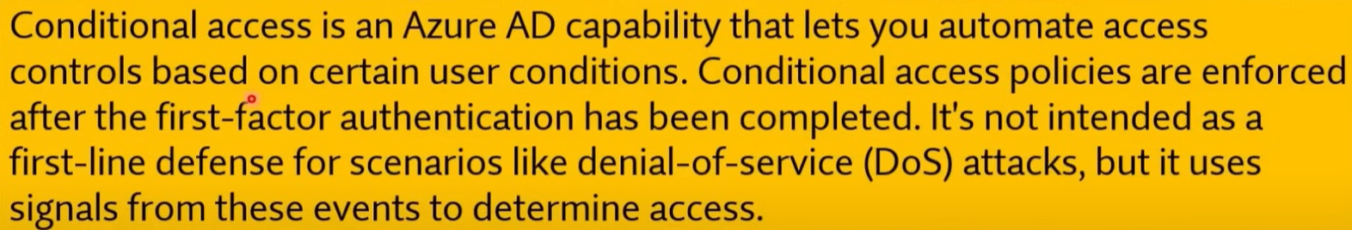

**Explanation:**

**Conditional Access** in Azure Active Directory (Azure AD) (Microsoft Entra ID) uses **signals** collected during the sign-in process to decide whether to allow or deny access requests. These signals can include factors such as:

* **User location**
* **Device compliance**
* **Risk level of the sign-in**
* **User role**
* **Application being accessed**
* **Network location (IP address)**

Based on these signals, Conditional Access policies can enforce additional requirements such as Multi-Factor Authentication (MFA), blocking access, or allowing access under specific conditions.

Q570. Conditional Access brings signals together, to make decisions, and enforce organizational policies.

1. **Yes**
2. No

**Explanation:**

**Conditional Access** in Azure Active Directory (Azure AD) (Microsoft Entra ID) brings together various signals, such as user identity, location, device compliance, application, and risk level, to make real-time decisions about whether to grant or deny access. It enforces organizational policies by applying these conditions to ensure that only authorized users under specific circumstances can access resources, thereby enhancing security.

Q571. Your company is looking to build an authentication system.

**Solution: You recommend the use of Conditional Access.**

Does this meet the goal?

1. Yes
2. **No**

Q572. Conditional Access policies at their simplest are if-then statements.

1. **Yes**
2. No

Q573. What should you use to evaluate whether your company's Azure environment meets regulatory requirements?

1. **Azure Security Center (Microsoft Defender for Cloud)**
2. Azure Advisor
3. Azure Service Health
4. Azure Knowledge Center

Q574. What can you use to identify underutilized or unused Azure virtual machines?

1. **Azure Advisor**
2. Azure Cost Management + Billing
3. Azure reservations
4. Azure Policy

* <https://learn.microsoft.com/en-us/azure/advisor/advisor-cost-recommendations>

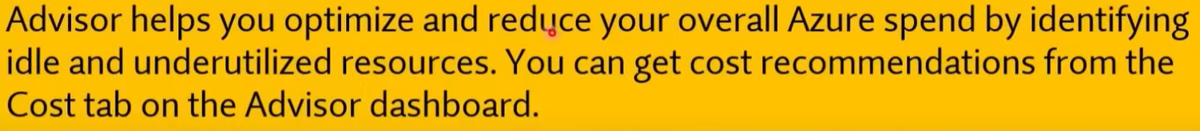

Q575. You have an Azure subscription. You have 100 Azure virtual machines. You need to quickly identify underutilized virtual machines that can have their service tier changed to a less expensive offering. Which blade should you use?

1. Metrics
2. Customer insights
3. Azure Monitor
4. **Azure Advisor**

Q576. Who can use the Azure Total Cost of Ownership (TCO) calculator?

1. Billing readers for an Azure subscription only
2. Owners for an Azure subscription only
3. **Anyone**
4. All users who have an account in Azure Active Directory (Azure AD) (Microsoft Entra ID) that is linked to an Azure subscription only



Q577. You have an azure virtual machine named VM1 .You plan to encrypt VM1 by using Azure Disk Encryption. Which Azure resource must you create first?

1. An Azure Storage account
2. An Azure Information Protection policy
3. An Encryption Key
4. **An Azure Key Vault**

Q578. You need to be notified when Microsoft plans to perform maintenance that can affect the resources deployed to an Azure subscription. What should you use?

1. Azure Monitor
2. **Azure Service Health**
3. Azure Advisor
4. Microsoft Trust Center

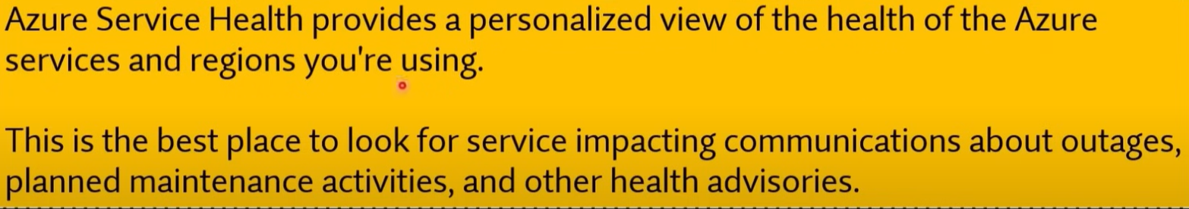

Q579. Your company has an Azure subscription that contains resources in several regions. You need to ensure that administrators can only create resources in those regions. What should you use?

1. a read-only lock
2. **an Azure policy**
3. a management group
4. a reservation

Q580. Your company has a Software Assurance agreement that includes Microsoft SQL Server licenses. You plan to deploy SQL Server on Azure virtual machines. What should you do to minimize licensing costs for the deployment?

1. Deallocate the virtual machines during off hours.
2. **Use Azure Hybrid Benefit.**
3. Configure Azure Cost Management budgets.
4. Use Azure reservations

* <https://azure.microsoft.com/en-us/pricing/hybrid-benefit/#overview>

**Explanation:**

The **Azure Hybrid Benefit** allows you to use your **existing SQL Server licenses** (with Software Assurance) to reduce the costs of running SQL Server on Azure Virtual Machines. By leveraging Azure Hybrid Benefit, you can save significantly on licensing costs because you're only paying for the underlying compute resources on Azure, not for new SQL Server licenses.

**Other Options:**

* **a. Deallocate the virtual machines during off hours**: This can help reduce compute costs but does not directly impact licensing costs.
* **c. Configure Azure Cost Management budgets**: This helps monitor and control overall costs but doesn't specifically reduce licensing costs.
* **d. Use Azure reservations**: While Azure Reservations can help reduce costs by committing to long-term usage, they focus on compute cost savings rather than licensing savings. Azure Hybrid Benefit is specifically for reducing licensing costs.

Q581. This question requires that you evaluate the underlined text to determine if it is correct.

From Azure Monitor you can view which user turned off a specific virtual machine during the last 14 days.

Instructions: Review the underlined text. If it makes the statement correct, select "No change is needed". If the statement is incorrect, select the answer choice that makes the statement correct.

1. No change is needed
2. Azure Event Hubs
3. **Azure Activity Log**
4. Azure Service Health

Q582. The Microsoft Service Trust portal can be accessed by using a Microsoft cloud services account

1. **Yes**
2. No

Q583. Compliance Manager can be used to track your company's regulatory compliance activities related to Microsoft cloud services.

1. **Yes**
2. No

Q584. The My Library feature can be used to save Microsoft Service Trust Portal documents and resources in a single location.

1. **Yes**
2. No

* <https://learn.microsoft.com/en-us/purview/get-started-with-service-trust-portal#my-library>

Q585. A window Virtual desktop session host can run Windows 10 only.

1. Yes
2. **No**

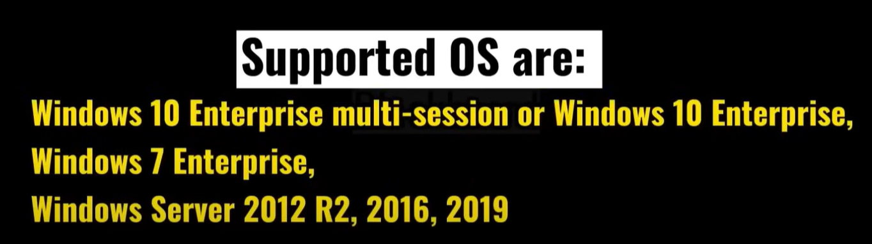

Q586. A window Virtual desktop host pool that includes 20 session hosts supports a maximum of 20 simultaneous user connections.

1. Yes
2. **No**

**Explanation:**

In **Windows Virtual Desktop (WVD)** or **Azure Virtual Desktop (AVD)**, a **host pool** can contain multiple session hosts, and the number of **simultaneous user connections** supported depends on the configuration and resources (like CPU, memory, etc.) of each session host, **not on the number of session hosts**.

Typically, a session host can support multiple user sessions at the same time. For example, each session host could handle several users depending on the resource allocation per user. If your host pool includes 20 session hosts, it could support far more than 20 users, depending on the sizing and scaling of the session hosts.

Q587. A window Virtual desktop support desktop and app virtualization.

1. **Yes**
2. No

Q588. Azure Dev0ps services allows developer to deploy or update applications to Azure using continuous integration/continuous delivery (CI/CD) pipelines.

1. **Yes**
2. No

Q589. Azure DevOps services include a Git repository for developers to store code.

1. **Yes**
2. No

Q590. Azure DevOps services can be used to build and host web apps.

1. Yes
2. **No**

Q591. A company wants to have an Enterprise messaging solution integrated with their existing application hosted within Microsoft Azure. Which of the following should the company use for this requirement?

1. Logic Apps
2. API Management Services
3. **Service Bus**
4. Data Factories
5. API Connections

**Explanation:**

**Azure Service Bus** is an enterprise-level **messaging solution** that provides reliable and secure message communication between distributed applications. It allows applications to exchange messages and can integrate with other Azure services or external systems. **Azure Service Bus** is ideal for scenarios such as order processing, payment workflows, or any messaging system where reliability, queue management, and decoupling are required.

**Other Options:**

* **a. Logic Apps**: This is a workflow automation service but not primarily a messaging solution.
* **b. API Management Services**: This is used to manage APIs, not for enterprise messaging.
* **d. Data Factories**: This service is used for data integration and ETL (Extract, Transform, Load) processes.
* **e. API Connections**: This is typically used to connect different APIs but not designed for enterprise-level messaging.

Q592. Which service provides access to unused Azure compute capacity at deep discounts?

1. Azure container instances
2. Azure reserved machine
3. **Azure spot virtual machine instances**
4. Azure virtual machine scale sets

* <https://azure.microsoft.com/en-us/products/virtual-machines/spot/>

Q593. Azure Site Recovery provides ___________ for virtual machines.

1. fault tolerance
2. **disaster recovery**
3. elasticity
4. high availability

Q594. Azure Virtual Machines offer less control over the computing environment than the other compute offerings.

1. Yes
2. **No**

**Explanation:**

**Azure Virtual Machines (VMs)** actually offer **more control** over the computing environment compared to other compute offerings like **Platform as a Service (PaaS)** solutions. With Azure VMs, you can fully control the operating system, install and configure any software, manage security, and more. You are responsible for managing and maintaining the VM, including patching, updates, and scaling.

In contrast, services like **Azure App Service** or **Azure Functions** (which are PaaS or serverless offerings) abstract much of the underlying infrastructure and provide less control, focusing more on ease of use and automated management.

Q595. This question requires that you evaluate the underlined text to determine if it is correct.

When you are implementing software as a service (SaaS) solution, you are responsible for configuring high availability.

Instructions: Review the underlined text. If it makes the statement correct, select "No change is needed". If the statement is incorrect, select the answer choice that makes the statement correct.

* No change is needed.
* defining scalability rules
* installing the SaaS solution
* **configuring the SaaS solution**

Q596. This question requires that you evaluate the underlined text to determine if it is correct.

A support plan solution that gives you best practice information, health status and notifications, and 24/7 access to billing information at the lowest possible cost is a Standard support plan.

Instructions: Review the underlined text. If it makes the statement correct, select "No change is needed". If the statement is incorrect, select the answer choice that makes the statement correct.

1. No change is needed
2. Developer
3. **Basic**
4. Premier

Q597. You plan to use Azure to host two apps named App1 and App2. The apps must meet the following requirements:

* You must be able to modify the code of App1.
* Administrative effort to manage the operating system of App1 must be minimized.
* App2 must run interactively with the operating system of the server.

Which type of cloud service should you use for each app?

To answer, select the appropriate options in the answer area. NOTE: Each correct selection is worth one point.

A. APP1

1. Infrastructure as a Service (laaS)
2. **Platform as a Service (PaaS)**
3. Software as a Service (SaaS)

B. APP2

1. Infrastructure as a Service (laaS)
2. Platform as a Service (PaaS)
3. **Software as a Service (SaaS)**

Q598. To answer, drag the appropriate benefit from the column on the left to its description on the right. Each benefit may be used once, more than once, or not at all.

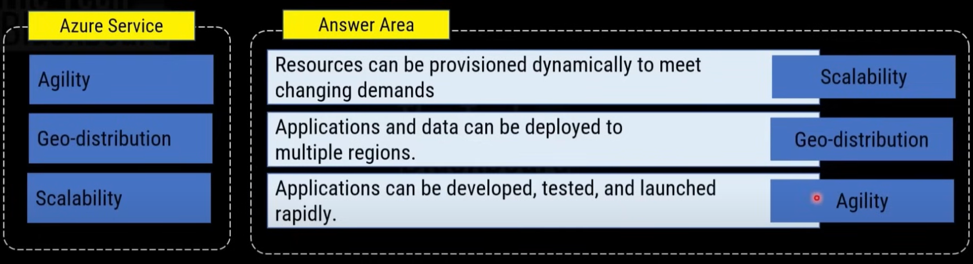

Q599. This question requires that you evaluate the underlined text to determine if it is correct.

Azure policies provide a common platform for deploying objects to a cloud infrastructure and for implementing consistency across the Azure environment.

Instructions: Review the underlined text. If it makes the statement correct, select "No change is needed". If the statement is incorrect, select the answer choice that makes the statement correct.

1. No change is needed
2. Resource groups
3. **Azure Resource Manager**
4. Management groups

**Explanation:**

The underlined text is incorrect. **Azure Resource Manager (ARM)** is the service that provides a common platform for deploying resources (objects) to a cloud infrastructure and implementing consistency across the Azure environment. ARM allows you to manage infrastructure through templates, policies, and role-based access control (RBAC), ensuring consistency and repeatability in your Azure deployments.

* **Azure policies** are used to enforce rules and compliance but do not handle resource deployment directly.
* **Resource groups** organize resources but don't provide a common platform for deploying them.
* **Management groups** organize subscriptions, but they don't handle resource deployment directly either.

Q600. This question requires that you evaluate the underlined text to determine if it is correct.

An Azure region contains one or more data centers that are connected by using a low-latency network.

Instructions: Review the underlined text. If it makes the statement correct, select "No change is needed". If the statement is incorrect, select the answer choice that makes the statement correct.

1. **No change is needed**
2. Is found in each country where Microsoft has a subsidiary office
3. Can be found in every country in Europe and the Americas only
4. Contains one or more data centers that are connect by using a high-latency network

Q601. Support from MSDN forums is only provided to companies that have a pay-as-you-go subscription.

1. Yes
2. **No**

**Explanation:**

Support from **MSDN (Microsoft Developer Network) forums** (now known as Microsoft Q&A) is **available to everyone**, including those with **free, pay-as-you-go, and other subscription types**. MSDN forums provide community-driven support, where users can ask and answer questions about Microsoft products, including Azure. It is not limited to companies with a pay-as-you-go subscription, and anyone can access this community support platform.

For more comprehensive or official support, such as direct technical support from Microsoft, a paid **support plan** may be required.



Q602. To answer, drag the appropriate benefit from the column on the left to its description on the right. Each benefit may be used once, more than once, or not at all.

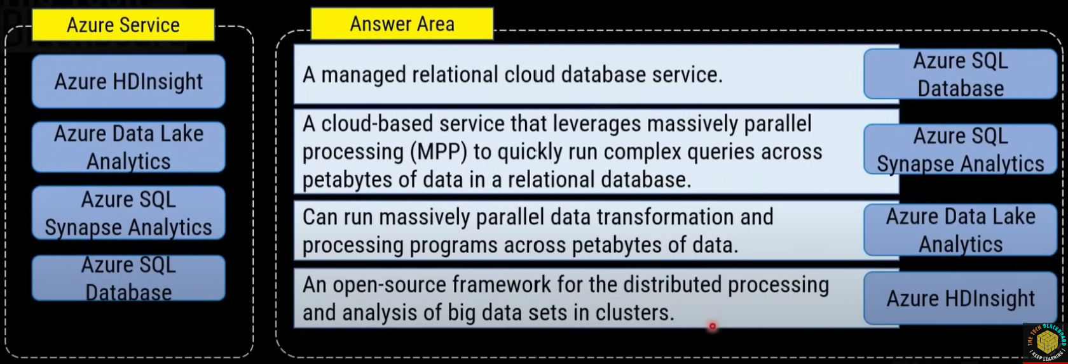

Q603. You need to identify which blades in the Azure portal must be used to perform the following tasks:

A. Monitor the health of Azure services:

1. **Azure Monitor**
2. Azure Subscriptions
3. Marketplace
4. Azure Advisor

B. View security recommendations:

1. Azure Monitor
2. Azure Subscriptions
3. Marketplace
4. **Azure Advisor**

C. Browse available virtual machine images.

1. Azure Monitor
2. Azure Subscriptions
3. **Marketplace**
4. Azure Advisor

Q604. Which Azure service should you use to check your secure score?

1. **Microsoft defender**
2. Azure Arc
3. DDoS Protection
4. Azure Firewall

* <https://learn.microsoft.com/en-us/azure/defender-for-cloud/secure-score-access-and-track>

Q605. You can manage an on-premises Windows server as an Azure resource by using:

1. Azure AB connect
2. Azure pipelines agent
3. Azure VPN Gateway
4. **Azure Arc**

**Explanation:**

**Azure Arc** enables you to manage on-premises Windows servers, Linux servers, and other resources **as if they were Azure resources**. This allows you to use Azure tools like Azure Policy, Azure Monitor, and security services to manage these on-premises servers, providing centralized management across both on-premises and Azure environments.

**Other Options:**

* **a. Azure AD Connect**: This is used to synchronize on-premises Active Directory with Azure Active Directory, but it does not manage on-premises servers as Azure resources.
* **b. Azure Pipelines Agent**: This is used to automate deployment pipelines in Azure DevOps but does not manage servers.
* **c. Azure VPN Gateway**: This is used to establish secure connections between on-premises networks and Azure but does not manage on-premises servers as Azure resources.

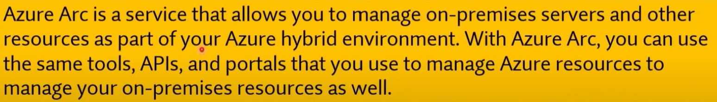

Q606. Which of the following services is a cloud-based network security service that helps to protect the resources that are stored in an Azure Virtual Network?

1. Azure Sentinel
2. Azure Key Vault
3. Azure Dedicated Hosts
4. **Azure Firewall**

**Explanation:**

**Azure Firewall** is a **cloud-based network security service** that helps protect resources within an Azure Virtual Network. It is a fully managed service that filters both inbound and outbound traffic based on rules you define and supports logging and threat intelligence-based filtering. It provides advanced features such as application filtering, network filtering, and integration with other Azure security services.

**Other Options:**

* **a. Azure Sentinel**: This is a cloud-native Security Information and Event Management (SIEM) and Security Orchestration Automated Response (SOAR) solution, not specifically a network security service for protecting Azure Virtual Networks.
* **b. Azure Key Vault**: This is a service used to store and manage secrets, encryption keys, and certificates, not for network security.
* **c. Azure Dedicated Hosts**: This is a service that provides dedicated physical servers for hosting Azure virtual machines, but it is not a network security service.

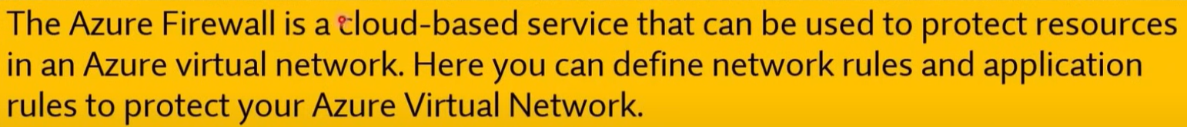

Q607. _________ refers to the ability to increase or decrease resources for a given workload.

1. Scalability
2. **Elasticity**
3. Agility
4. Resiliency

Q608. Which of the following is referred as logic implementation into readily available blocks of code?

1. Azure Logic App
2. Azure App Service
3. Azure ARM Template
4. **Azure Functions**

Q609. A company is planning to set up a solution on the Azure platform. The solution has the following main key requirement.

* Provide a managed service that could be used to manage and scale container-based applications.

Which of the following would be best suited for this requirement?

1. Azure Event Grid
2. Azure DevOps
3. **Azure Kubernetes**
4. Azure Dev Test Labs

Q610. A company is planning to set up a solution in Azure. The solution would have the following key requirement.

* A tool that provides guidance and recommendations to improve an Azure environment

Which of the following would be best suited for this requirement?

1. **Azure Advisor**
2. Azure Cognitive Services
3. Azure Application Insights
4. Azure DevOps

Q611. A company is planning to set up a solution in Azure. They have the following key requirements.

* Give the ability to process data from millions of sensors.

Which of the below Azure services can be used for this purpose?

1. Azure Machine Learning
2. **Azure IOT Hub**
3. Azure Al Bot
4. Azure Functions

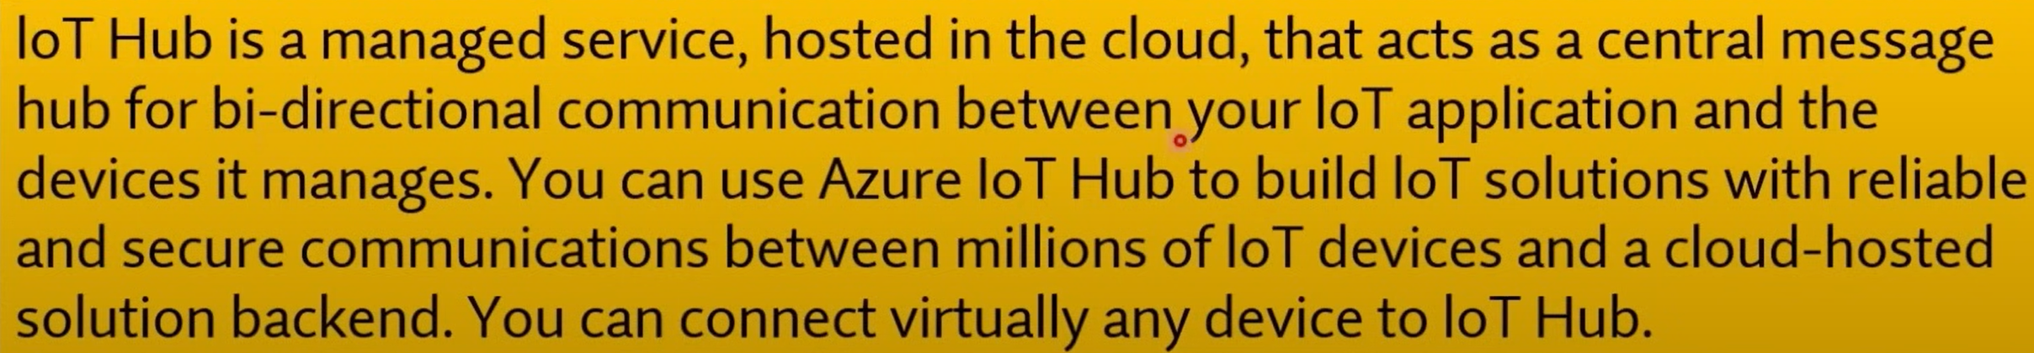

Q612. A company is planning to set up a solution in Azure. The solution would have the following key requirement.

* An Integration solution for the deployment of code

Which of the following would be best suited for this requirement?

1. Azure Advisor
2. Azure Cognitive Services
3. Azure Application Insights
4. **Azure DevOps**

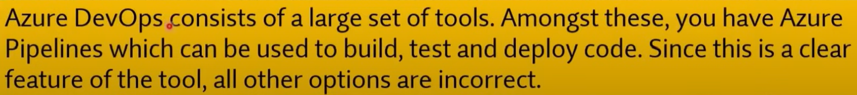

Q613. Your company is planning on hosting resources using Azure services. You have to decide on the right service to use for the desired requirement. Which of the following would you use for the following requirement?

* Provide a service that is used to integrate bots with applications

Which of the following would be best suited for this requirement?

1. Azure Cognitive Service
2. Azure DevOps
3. **Azure Bot service**
4. Azure Synapse Analytics

Q614. Your company is planning on hosting resources using Azure services. You have to decide on the right service to use for the desired requirement. Which of the following would you use for the following requirement?

* Provide a service that is used to add artificial intelligence features to applications

Which of the following would be best suited for this requirement?

1. **Azure Cognitive Service**
2. Azure DevOps
3. Azure Bot service
4. Azure Synapse Analytics

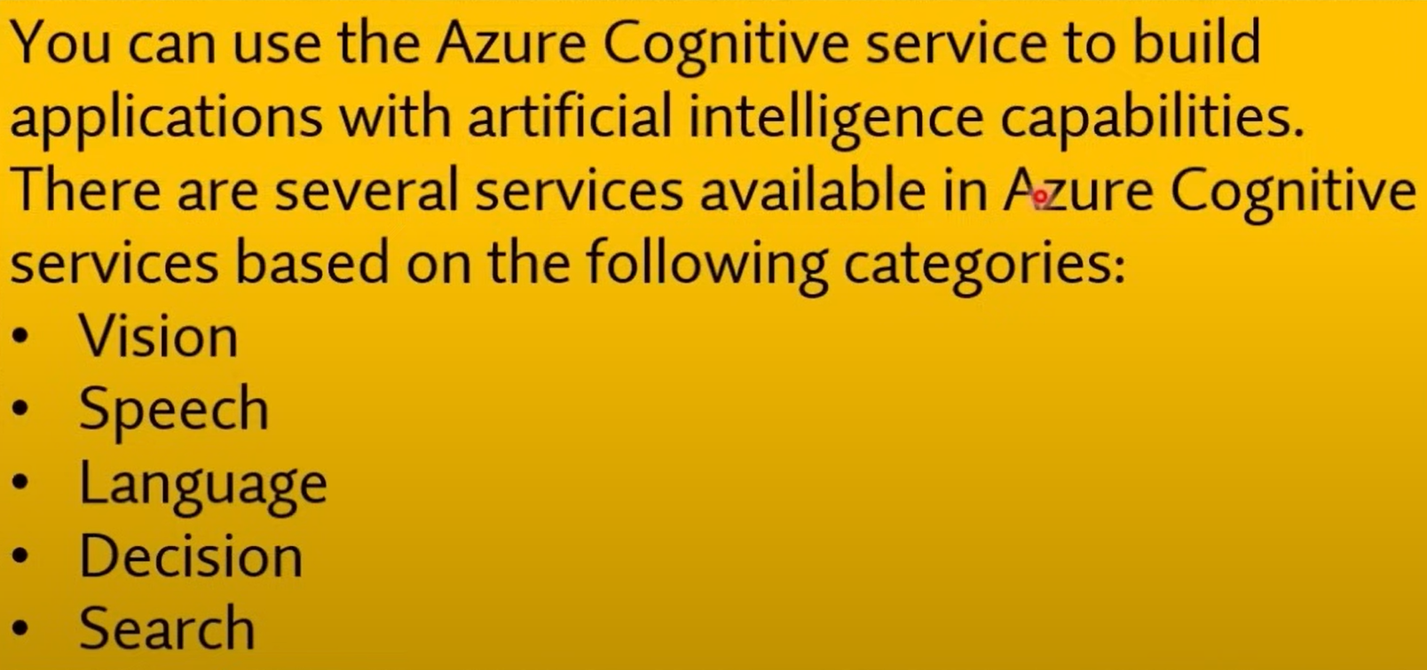

Q615. Which offering below uses inbound and outbound rules to filter network traffic to and from Azure resources connected to Azure Virtual Networks?

1. Public Load Balancer
2. Internal Load Balancer
3. Application Security Group
4. **Network Security Group**

Q616. Which offering to use to configure network security as an extension of an application's structure?

1. Public Load Balancer
2. Internal Load Balancer
3. **Application Security Group**
4. Network Security Group

* <https://learn.microsoft.com/en-us/azure/virtual-network/application-security-groups>

Q617. Deploying a solution using Azure Container Instances requires you to manage virtual machines.

1. Yes
2. **No**

**Explanation**:  
Azure Container Instances (ACI) is a serverless container service that allows you to run containers without having to manage the underlying virtual machines. ACI abstracts the infrastructure management, allowing you to deploy and scale containers quickly without worrying about VMs or their configurations.

Q618. The Azure App Service is an HTTP-based service for hosting web applications, REST APIs, and mobile back ends.

1. **Yes**
2. No

Q619. High Availability refers to the ability to keep services up and running for long periods of time, while experiencing little to no downtime.

1. **Yes**
2. No

Q620. Which service below is Microsoft's managed network security service in Azure that protects Azure Virtual Network resources?

1. Azure Bastion
2. **Azure Firewall**
3. Application Security Group
4. Azure Sentinel

**Explanation**:  
**b. Azure Firewall** is Microsoft's managed network security service in Azure that protects Azure Virtual Network resources. It is a cloud-based network security service that allows you to control both inbound and outbound traffic through defined rules, including network filtering and application-level filtering.

**Other Options**:

* **a. Azure Bastion**: This service provides secure RDP and SSH connectivity to virtual machines without exposing them to the internet, but it is not a network security service like a firewall.
* **c. Application Security Group**: This allows for the grouping of VMs in a virtual network to manage network security rules, but it is not a standalone network security service.
* **d. Azure Sentinel**: This is a cloud-native Security Information and Event Management (SIEM) tool for monitoring and detecting security threats, but it does not function as a network security service.

Q621. Your company wants to migrate its web server and database server to Microsoft Azure. The architecture diagram is shown below.

You must ensure that traffic restrictions are in place so that the database server can only communicate with the web server.

Which of the following would you recommend for implementing these restrictions?

* + 1. **Network Security Groups (NSGs)**
    2. Application Security Groups
    3. A Local Network Gateway
    4. A Virtual Network Gateway

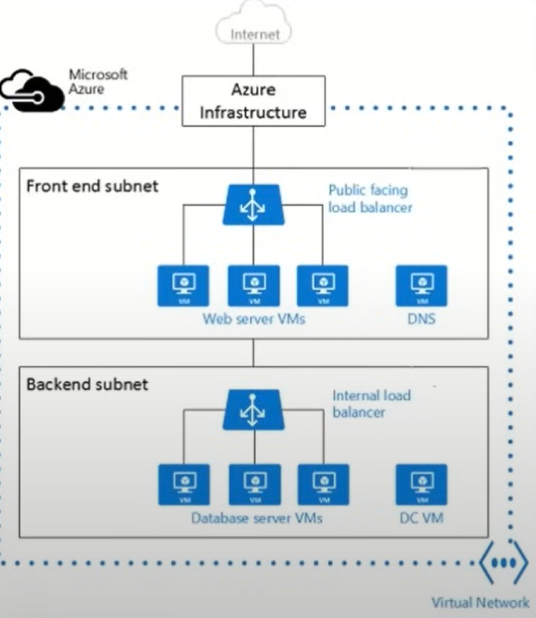

Q622. The Azure service displays recent activity by the virtual machine, including any configuration changes and when it was stopped and started?

1. Azure Monitor
2. **Activity Log**
3. Azure Advisor
4. Azure Agent

* <https://learn.microsoft.com/en-us/azure/virtual-machines/monitor-vm>

Q623. You can view Activity log in the Azure portal.

1. **Yes**
2. No

Q624. A company is planning to use Azure Synapse Analytics for hosting their sales historical data. Which of the following is a feature of the Azure Synapse SQL architecture?

1. High Availability
2. **Scalability**
3. Disaster Recovery
4. Visualization

Q625. You can create a diagnostic setting to send Activity Log to a Log Analytics workspace, where you can view events over time or analyze them with other collected data.

1. **Yes**
2. No

Q626. You can collect Windows event log data sources with Log Analytics agent.

1. **Yes**
2. No

* <https://learn.microsoft.com/en-us/azure/azure-monitor/agents/data-sources-windows-events>

**Explanation**:  
The **Log Analytics agent** can collect Windows event log data sources. It allows you to collect telemetry data, including performance metrics and event logs, from both Windows and Linux machines, and then send that data to Azure Monitor for further analysis and visualization.

Q627. Your company has several resources hosted in Azure. They want to have a comprehensive solution for collecting, analyzing, and acting on telemetry from the Azure cloud.

Which of the following services would you use for this requirement?

1. Azure Event Hubs
2. Azure Analysis Services
3. Azure Advisor
4. **Azure Monitor**

**Explanation**:  
**d. Azure Monitor** is the service that provides a comprehensive solution for collecting, analysing, and acting on telemetry from Azure cloud resources. It helps you monitor your applications, infrastructure, and network performance, and it integrates with other services for alerting, dashboards, and automation.

**Other Options**:

* **a. Azure Event Hubs**: This is a big data streaming platform and event ingestion service, but it is not specifically for monitoring and telemetry.
* **b. Azure Analysis Services**: This is used for data modelling and analytics, not for collecting or analysing telemetry.
* **c. Azure Advisor**: This provides personalized best practice recommendations for your Azure resources but is not designed for telemetry and monitoring.

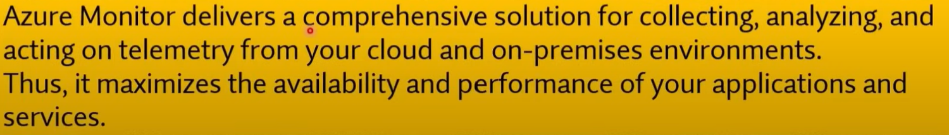

Q628. Your company wants to use Azure Storage Accounts. They have the following requirements. Storage Account should automatically replicate data to the secondary region.

**Solution: Configuring the Read-Access Geo-Redundant Storage Account as it automatically replicates data to the secondary region?**

Does this solution meet the goal?

1. **Yes**
2. No

Q629. A company wants to ensure that users in their company are authenticated when they access resources defined in their Microsoft Azure account. Which of the following is the correct definition of authentication?

1. This specifies the type of service you can use in Azure
2. This specifies the type of data you can use in Azure
3. **This is the act of providing legitimate credentials**
4. This specifies what you can do in Azure



Q630. Your company has 10 offices. You plan to generate several billing reports from the Azure portal. Each report will contain the Azure resource utilization of each office. Which Azure Resource Manager feature should you use before you generate the reports?

1. **tags**
2. templates
3. locks
4. policies

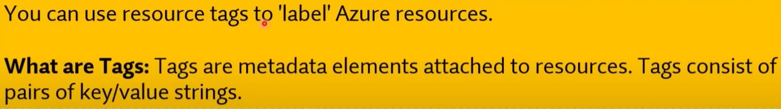

Q631. You need to configure an Azure solution that meets the following requirements:

1. Secures websites from attacks
2. Generates reports that contain details of attempted attacks

What should you include in the solution?

1. Azure Firewall
2. a network security group (NSG)
3. Azure Information Protection
4. **DDoS protection**



Q632. A company wants to create multiple data stores in Microsoft Azure. They want to have storage layers that can be used to store data that is infrequently used.

Which of the following storage tiers for Azure BLOB storage would be suitable for this type of requirement? Choose 2 answers from the options given below.

1. Premium storage
2. Hot storage
3. **Cool storage**
4. **Archive storage**

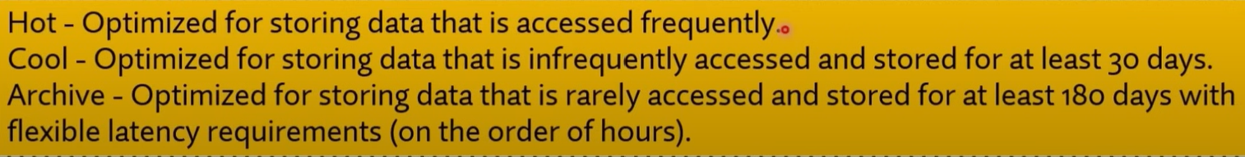

Q633. An IT Engineer needs to create a Virtual Machine in Microsoft Azure. Currently the IT Engineer has an Android OS based workstation.

Which of the following can the IT Engineer use to create the desired Virtual Machine in Azure?

1. Microsoft PowerApps
2. **Azure Cloud Shell**
3. **Azure Power Shell**
4. Azure CLI

Q634. Your company is planning on using Azure AD (Microsoft Entra ID) for authentication of the resources defined in Azure. Does Azure AD (Microsoft Entra ID) have built-in capabilities for securing authentication and authorization to resources?

1. **Yes**
2. No

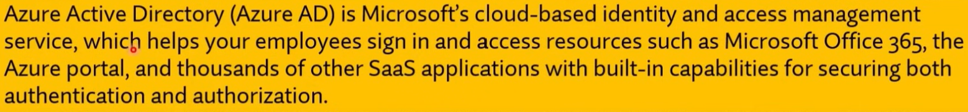

Q635. A company is planning on setting up an Azure Free Account. Does the Basic Support plan come along with the Azure Free Account?

1. **Yes**
2. No

Q636. A company is planning on using their Microsoft Azure Free Account for hosting production-based resources. Does the Azure Free Account allow you to host production-based resources?

1. **Yes**
2. No
3. <https://azure.microsoft.com/en-us/pricing/purchase-options/azure-account?icid=azurefaq>
4. The Azure free account provides access to all Azure services and does not block customers from building their ideas into production. The Azure free account includes certain types of specific services—and certain amounts of those services—for free. To enable your production scenarios, you may need to use resources beyond the free amounts. If you choose to move to pay as you go, you’ll be billed for those additional resources at pay-as-you-go rates.

Q637. Can you apply any of your $200 credit toward Azure Marketplace offers?

1. Yes
2. **No**



Q638. Can you spend your credit on Azure Spot Virtual Machines?

1. Yes
2. **No**



Q639. Can you use your Azure Hybrid Benefit within the Azure free account?

1. Yes
2. **No**



Q640. Geo-redundant storage (GRS) duplicates information to a secondary place over multiple data centers that are located many kilometers apart.

1. **Yes**
2. No



Q641. A company wants to implement an IOT solution service available in Microsoft Azure.

Which of the following would meet the below requirement?

**"Monitor and control millions of Internet of Things (IOT) assets".**

1. **IOT Hub**
2. IOT Central
3. IOT Edge
4. Azure Time Series Insights

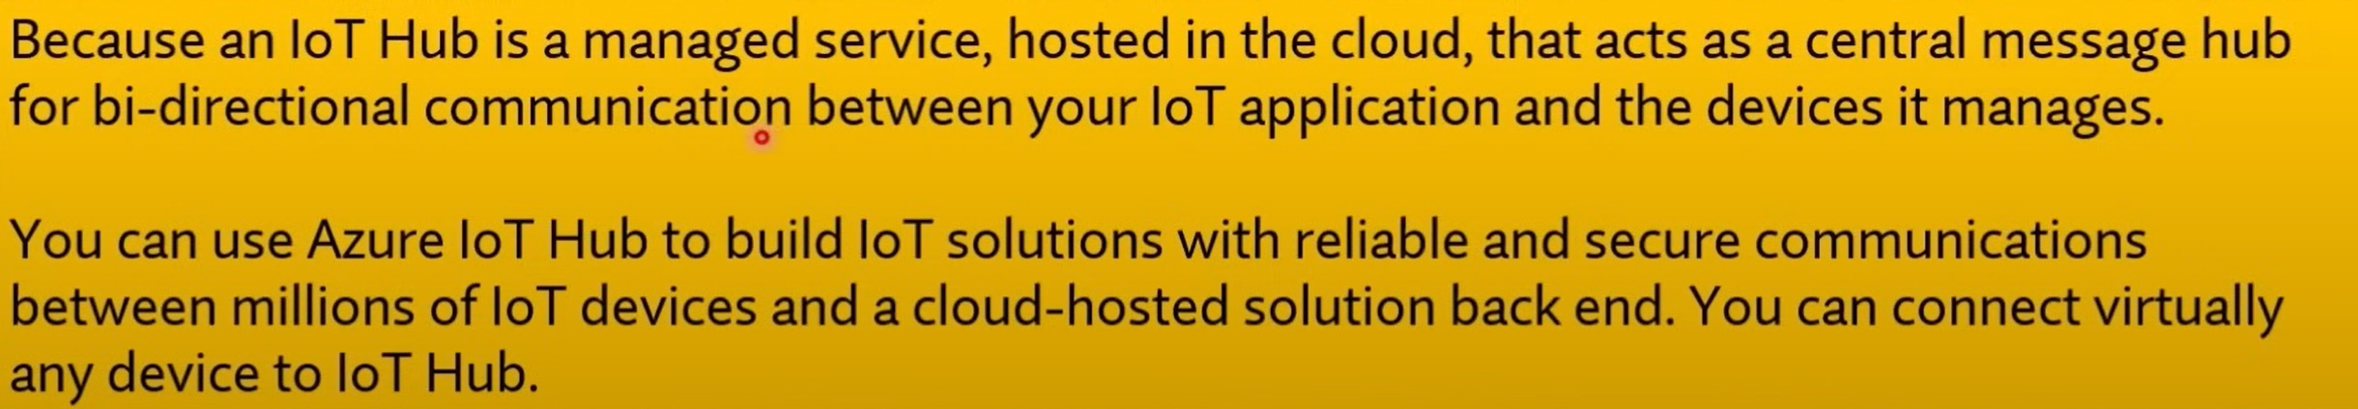

Q642. A company wants to implement an IOT solution service available in Microsoft Azure.

Which of the following would meet the below requirement?

**"Used to analyze data on end user devices".**

1. IOT Hub
2. IOT Central
3. **IOT Edge**
4. Azure Time Series Insights
5. <https://learn.microsoft.com/en-us/azure/iot-edge/about-iot-edge?view=iotedge-1.4>

Q643. A company wants to implement an IOT solution service available in Microsoft Azure.

Which of the following would meet the below requirement?

**"Provides a fully managed aPaaS (application platform as a service) solution that makes it easy to connect, monitor and manage IOT assets at scale".**

1. Hub
2. **IOT Central**
3. IOT Edge
4. Azure Time Series Insights
5. <https://learn.microsoft.com/en-us/azure/iot-central/core/overview-iot-central>

Q644. A company wants to implement an IOT solution service available in Microsoft Azure.

Which of the following would meet the below requirement?

**"Helps provide powerful data exploration and telemetry tools to help refine operational analysis".**

1. IOT Hub
2. IOT Central
3. IOT Edge
4. **Azure Time Series Insights**
5. <https://learn.microsoft.com/en-us/azure/time-series-insights/migration-to-fabric>
6. Time Series Insights is a service that enables operational analytics and reporting on historical data. It offers data ingestion, storage, contextualization, analysis, and querying capabilities. As part of migrating to [Real-Time Intelligence](https://learn.microsoft.com/en-us/fabric/real-time-intelligence/overview), all of these capabilities can be met and even improved by migrating to [Eventhouse](https://learn.microsoft.com/en-us/fabric/real-time-intelligence/eventhouse), the time series database in Real-Time Intelligence.

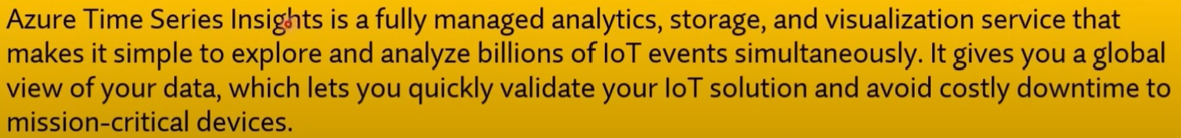

Q645. A company is planning on hosting 2 Virtual Machines in Azure as shown below:

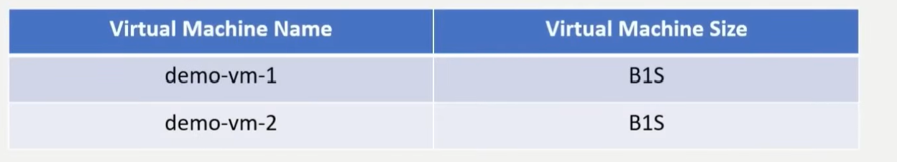

When the virtual machine demo-vm-1 is stopped, you will still incur costs for the storage attach to the Virtual Machine?

1. **Yes**
2. No

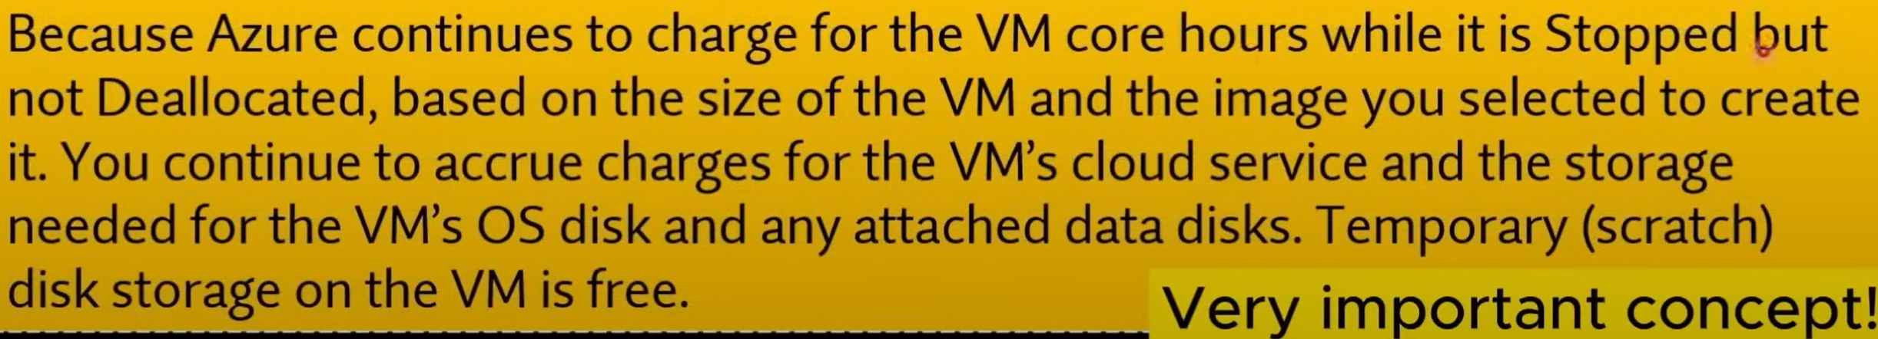

Q646. What is the function of a Site-to-Site VPN?

1. provides a secure connection between a computer on a public network and the corporate network
2. provides a dedicated private connection to Azure that does NOT travel over the internet
3. **provides a connection from an on-premises VPN device to an Azure VPN gateway**
4. <https://learn.microsoft.com/en-us/azure/vpn-gateway/tutorial-site-to-site-portal>

Q647. Which VPN is implied by "provides a dedicated private connection to Azure that does NOT travel over the internet"?

1. Site to Site VPN
2. Point to Site VPN
3. **ExpressRoute**
4. VNET

Q648. Which VPN is implied by "provides a secure connection between a computer on a public network and the corporate network"?

1. Site to Site VPN
2. **Point to Site VPN**
3. ExpressRoute
4. VNET

Q649. A company is planning to host an application on a set of Virtual Machines in Azure. They want to ensure that the application recovers from a region-wide failure in Azure. Which of the following concepts needs to be considered to fulfil this requirement?

1. Scalability
2. **Disaster Recovery**
3. Agility
4. Elasticity

Q650. An IT Engineer needs to create a Virtual Machine in Azure. Currently, the IT Engineer has a Windows desktop along with the Azure Command Line Interface (CLI).

Which of the following would allow the IT engineer to use the Azure Command Line Interface?

Choose 2 answers from the options given below.

1. **PowerShell**
2. File and Print Explorer
3. **Command Prompt**
4. Control Panel

Q651. A company is planning to set up a solution in Azure. The solution would have the following key requirement. Gives the ability to host a big data analysis service for machine learning.

Which of the following would be best suited for this requirement?

1. **Azure Databricks**
2. Azure Logic Apps
3. Azure App Service
4. Azure Application Insights
5. <https://learn.microsoft.com/en-us/azure/databricks/introduction/>

Q652. A company is planning on setting up a solution in Microsoft Azure. The solution would have the following key requirement:

1. An Integration solution for the deployment of code

Which of the following would be best suited for this requirement?

1. Azure Advisor
2. Azure Cognitive Services
3. Azure Application Insights
4. **Azure DevOps**

Q653. A company is currently planning to deploy resources to Azure. They want to have the ability to manage user access to resources across multiple subscriptions.

Which of the following can help you achieve this requirement?

1. Resource Groups
2. **Management Groups**
3. Azure Policies
4. Azure App Service

Q654. A company is planning on hosting solutions on within Microsoft Azure Cloud. They need to implement MFA for identities hosted within Microsoft Azure.

Is it necessary to deploy a federation solution or sync on-premises identities to the cloud?

1. Yes
2. **No**
3. <https://learn.microsoft.com/en-us/azure/cloud-adoption-framework/decision-guides/identity/#determine-identity-integration-requirements>

**Explanation**:  
It is **not necessary** to deploy a federation solution or sync on-premises identities to the cloud in order to implement Multi-Factor Authentication (MFA) for identities hosted within Microsoft Azure. Azure Active Directory (Azure AD) (Microsoft Entra ID) provides built-in MFA capabilities that can be enabled directly for cloud-only identities without the need for federation or on-premises identity synchronization.

Q655. A company is planning to set up a solution in Azure. The solution would have the following key requirement. Provide a cloud service that helps to transform data and provide valuable insights on the data itself.

Which of the following would be best suited for this requirement?

1. **Azure Data Lake Analytics**
2. Azure Virtual Machine Scale Sets
3. Azure Virtual Network
4. Azure App Service

Q656. A company wants to host a set of tables in Microsoft Azure. They want absolutely zero

administration of the underlying infrastructure and low latency access to data.

**You recommend using the Azure App service.**

Would this meet the requirement?

1. Yes
2. **No**



Q657. A company wants to host a set of tables in Microsoft Azure. They want absolutely zero

administration of the underlying infrastructure and low latency access to data.

**You recommend using the SQL Database service.**

Would this meet the requirement?

1. **Yes**
2. No



Q658. A company wants to host a set of tables in Microsoft Azure. They want absolutely zero

administration of the underlying infrastructure and low latency access to data.

**You recommend using the Cosmos DB service.**

Would this meet the requirement?

1. **Yes**
2. No



Q659. A company has a Virtual Machine created in their subscription. An application is installed on the Virtual Machine. You need to ensure that traffic can flow into the Virtual Machine on port 8080.

Which of the following must you modify to make this work?

1. Network Interface Card
2. **Network Security Group**
3. Route Tables
4. Route Filters

Q660. A company is planning on hosting a set of resources in Microsoft Azure. They want to protect their resources against DDoS attacks and also get real time attack metrics.

Which of the following should the company select to meet this requirement?

1. DDoS Protection Basic
2. **DDoS Protection Standard**
3. DDoS Protection Premium
4. DDoS Protection Isolated



Q661. A company is planning on deploying resources to a Resource Group (RG) within Microsoft Azure. The company is planning on assigning tags to the Resource Groups.

Would the resources in the Resource Group (RG) also inherit the same tags?

1. Yes
2. **No**



Q662. A company is planning on deploying resources to a Resource Group (RG) within Microsoft Azure. The company is planning on assigning permissions to the Resource Group (RG).

Would the resources within the Resource Group (RG) also inherit the same permissions?

1. **Yes**
2. No



Q663. A management group tree can support up to _____ levels of depth.

1. 2
2. 4
3. **6**
4. 8

Q664. How many management groups can be supported in a single directory.

1. 100
2. 1000
3. **10000**
4. 100000
5. <https://learn.microsoft.com/en-us/azure/governance/management-groups/overview>

Q665. Each management group and subscription can only support one parent.

1. **Yes**
2. No

Q666. A company is planning to set up a solution on the Azure platform. The solution has the following main key requirement. Provide a managed service that could be used to manage and scale container-based applications.

Which of the following would be best suited for this requirement?

1. Azure Event Grid
2. Azure DevOps
3. **Azure Kubernetes**
4. Azure DevTest Labs

Q667. Building a data center infrastructure is an example of operational expenditure (OpEx) costs.

1. True
2. **False**

Q668. Monthly salaries for technical personnel are an example of operational expenditure (OpEx) costs.

1. **True**
2. False

Q669. Leasing software is an example of operational expenditure (OpEx) costs.

1. **True**
2. False



Q670. The company is Leasing Software. Which category would the following expenses come under?

1. Primary Expenditure
2. Capital Expenditure
3. Secondary Expenditure
4. **Operating/Operational Expenditure**

Q671. Which of the following is true when it comes to SaaS (Software as a service)?

1. You are responsible for scalability of the solution
2. You are responsible for deploying the solution
3. **You are responsible for configuring the solution**
4. You are responsible for high availability of the solution

Q672. What are the additional dependent resources that an Azure virtual machine must have? (Select TWO)

1. Public IP
2. **Azure Virtual Network**
3. Data Disk
4. **NIC Card**

**Explanation**:

* **Azure Virtual Network (VNet)**: A virtual machine must be connected to a virtual network in Azure to communicate with other resources.
* **NIC Card**: A network interface card is required for the virtual machine to interact with the network.

**Other Options**:

* **a. Public IP**: A public IP address is optional and is only required if you want the VM to be accessible from the internet.
* **c. Data Disk**: A data disk is optional and is used for additional storage but not required to create a VM.



Q673. A company wants to migrate some scripts to Microsoft Azure. They want to make use of the serverless features available in Azure.

**Solution: They decide to use the Azure Virtual Machine service.**

Would this service meet the requirement?

1. Yes
2. **No**

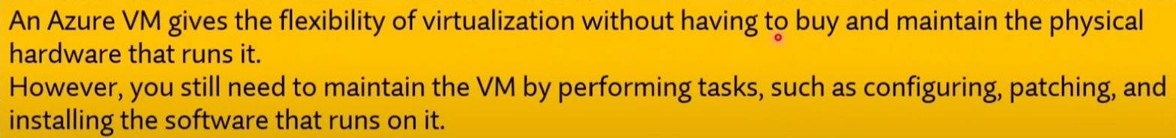

Q674. A company wants to migrate some scripts to Microsoft Azure. They want to make use of the serverless features available in Azure.

**Solution: They decide to use the Azure Functions service.**

Would this service meet the requirement?

1. **Yes**
2. No



Q675. A company wants to migrate some scripts to Microsoft Azure. They want to make use of the serverless features available in Azure.

**Solution: They decided to use the Azure Content Delivery Network service.**

Would this service meet the requirement?

1. Yes
2. **No**

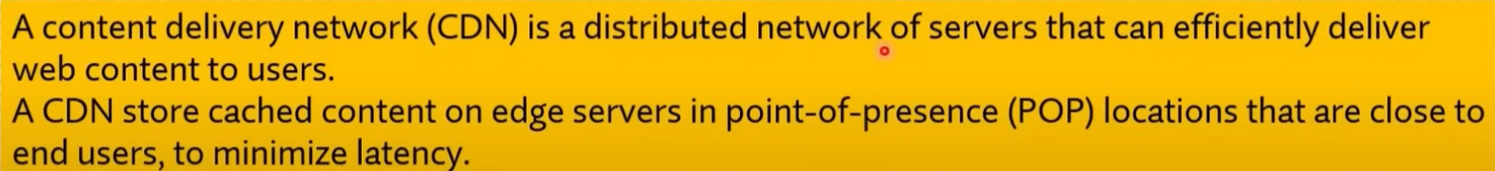

Q676. Is the Cool Access tier a good option for long-term backup?

1. Yes
2. **No**



Q677. Azure storage capacity limits are set at the account level?

1. **Yes**
2. No
3. <https://learn.microsoft.com/en-us/azure/storage/blobs/access-tiers-overview?tabs=azure-portal>
4. Azure storage capacity limits are set at the account level, rather than according to access tier.

Q678. Which of the following blob options in Azure Storage is ideal for spring text or binary files, and for uploading large files?

1. **Block Blobs**
2. Append Blobs
3. Page blobs.
4. <https://learn.microsoft.com/en-us/azure/storage/blobs/storage-blob-pageblob-overview?source=recommendations>
5. Azure Storage offers three types of blob storage: Block Blobs, Append Blobs and page blobs. Block blobs are composed of blocks and are ideal for storing text or binary files, and for uploading large files efficiently. Append blobs are also made up of blocks, but they are optimized for append operations, making them ideal for logging scenarios. Page blobs are made up of 512-byte pages up to 8 TB in total size and are designed for frequent random read/write operations. Page blobs are the foundation of Azure IaaS Disks.

Q679. A company wants to provision a solution within Microsoft Azure with the following requirements:

* Provision a WordPress solution
* Host the solution on a Virtual Machine

Which of the following could be used to quickly deploy the above solutions?

1. Virtual Machine Scale sets
2. Azure Resource Groups
3. **Azure Marketplace**
4. Azure Web Apps

**Explanation**:  
**Azure Marketplace** can be used to quickly deploy a pre-configured WordPress solution hosted on a Virtual Machine. The Azure Marketplace provides a variety of pre-built solutions, including WordPress, that can be deployed with just a few clicks.

**Other Options**:

* **a. Virtual Machine Scale sets**: This is used for deploying and managing a set of identical VMs, but it is not specifically for quickly provisioning a WordPress solution.
* **b. Azure Resource Groups**: This is used to manage and organize Azure resources, but it doesn't deploy specific solutions like WordPress.
* **d. Azure Web Apps**: This is a service for hosting web applications, but it is not used for deploying a WordPress solution on a VM.



Q680. Which of the following are factors that affect the compute cost of the virtual machines? (Choose Two)

1. **The size of the virtual machine**
2. The data center the virtual machine is located in
3. The resource group the virtual machine is located in
4. **The region the virtual machine is located in**

**Explanation**:

* **The size of the virtual machine**: Larger VM sizes with more CPU, memory, and storage resources cost more than smaller ones.
* **The region the virtual machine is located in**: Different Azure regions have varying pricing due to factors like demand and local operational costs.

**Other Options**:

* **b. The data centre the virtual machine is located in**: The specific data center within a region does not affect the cost; pricing is based on the Azure region.
* **c. The resource group the virtual machine is located in**: Resource groups are used for organizing resources, but they do not influence the cost of VMs.

Q681. You need to create a new user for an Azure subscription. What should you use?

To answer, select the service in the answer area. NOTE: Each correct match is worth one point.

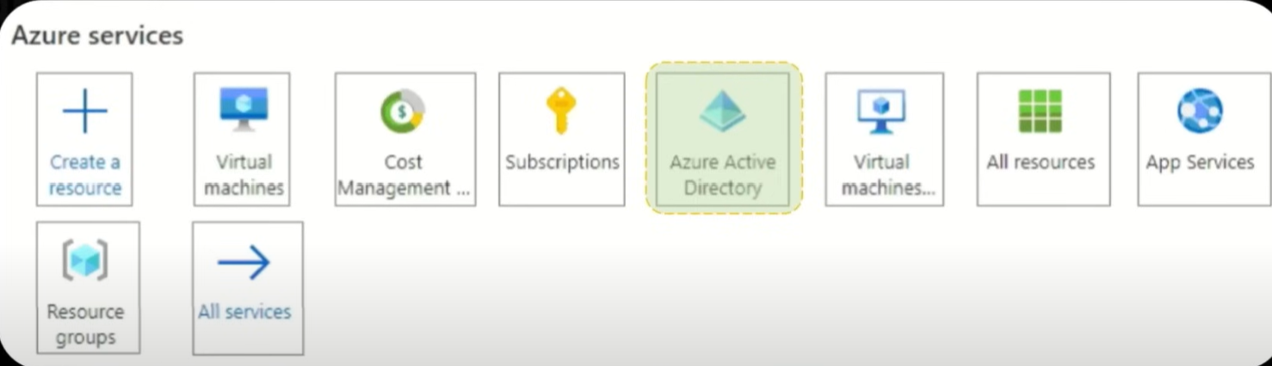



Q682. Which term represents the ability to increase the computing capacity of a virtual machine by adding memory or CPUs?

1. agility
2. **vertical scaling**
3. horizontal scaling
4. elasticity

Q683. Which term represents the ability to increase the computing capacity qf by adding more Virtual Machines?

1. agility
2. vertical scaling
3. **horizontal scaling**
4. elasticity

Q684. Scale-in and Scaling-out are related concepts to Horizontal Scaling.

1. **Yes**
2. No

**Explanation**:  
**Scale-in** and **Scale-out** are related to **Horizontal Scaling**. Scaling out refers to adding more instances or servers (increasing the number of resources), while scaling in refers to reducing the number of instances (decreasing resources). Both concepts involve adjusting the number of compute instances to handle varying workloads without changing the size of individual instances.

Q685. Scaling-up and Scaling-down are related concepts to Vertical Scaling.

1. **Yes**
2. No

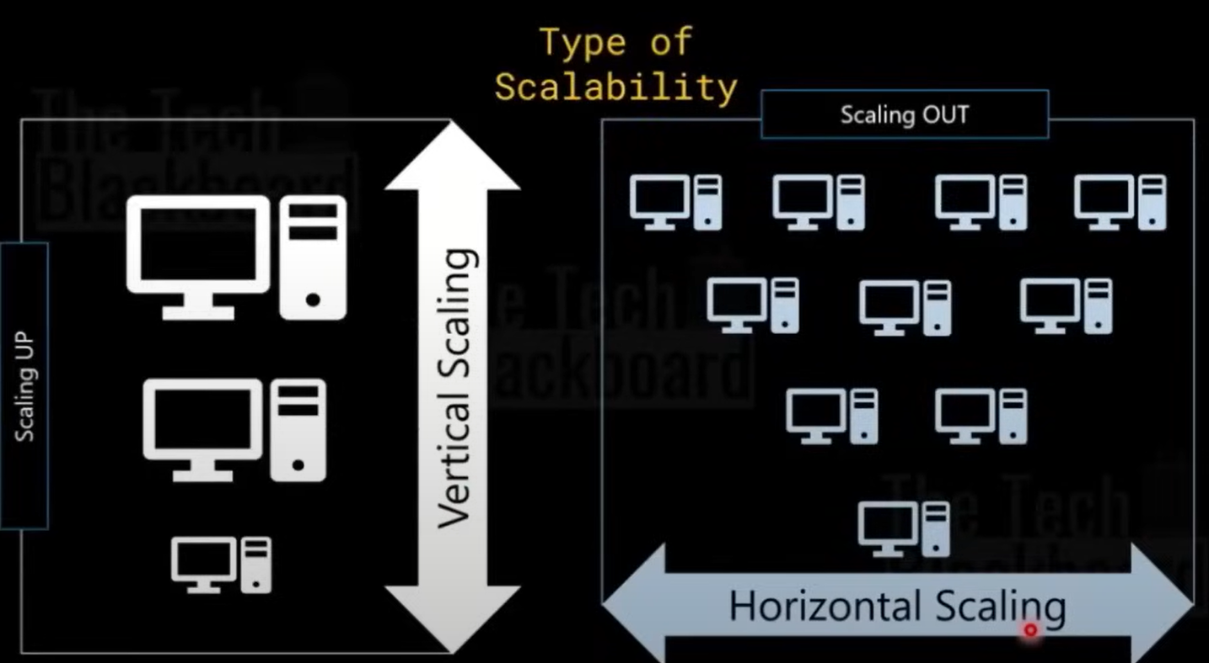

Q686. A company is planning on setting up a solution in Microsoft Azure. The solution would have the following key requirement:

* Provide a solution to host and manage a group of identical Virtual Machines.

Which of the following would be best suited for this requirement?

1. Azure Data Lake Analytics
2. **Azure Virtual Machine Scale Sets**
3. Azure Virtual Network
4. Azure App Service

* <https://learn.microsoft.com/en-us/azure/virtual-machine-scale-sets/overview>

**Explanation**:  
**Azure Virtual Machine Scale Sets** are designed to host and manage a group of identical virtual machines. They automatically distribute traffic among them and allow you to easily scale the number of VMs in or out based on demand, making it ideal for scenarios where you need a group of identical VMs to handle varying workloads.

**Other Options**:

* **a. Azure Data Lake Analytics**: This is used for big data analytics, not for managing virtual machines.
* **c. Azure Virtual Network**: This is used for networking and connecting Azure resources, but it does not manage virtual machines.
* **d. Azure App Service**: This is for hosting web apps and APIs, not for managing identical virtual machines.

Q687. A company is planning on setting up a solution in Microsoft Azure. The solution would have the following key requirement:

* Provide an isolated environment for hosting Virtual Machines.

Which of the following would be best suited for this requirement?

1. Azure Data Lake Analytics
2. Azure Virtual Machine Scale Sets
3. **Azure Virtual Network**
4. Azure App Service

**Explanation**:  
**Azure Virtual Network (VNet)** provides an isolated environment for hosting virtual machines and other Azure resources. It allows you to define private IP ranges, subnets, and control inbound and outbound traffic, ensuring that your virtual machines are hosted in a secure and isolated network environment.

**Other Options**:

* **a. Azure Data Lake Analytics**: This is for big data analytics, not for providing an isolated environment for virtual machines.
* **b. Azure Virtual Machine Scale Sets**: This is used for managing groups of identical virtual machines, but it does not provide network isolation.
* **d. Azure App Service**: This is for hosting web applications and APIs, not for creating isolated environments for virtual machines.



Q688. A company is planning on setting up a solution in Microsoft Azure. The solution would have the following key requirement:

* Provide a cloud service that helps to transform data and provide valuable insights on the data itself.

Which of the following would be best suited for this requirement?

1. **Azure Data Lake Analytics**
2. Azure Virtual Machine Scale Sets
3. Azure Virtual Network
4. Azure App Service



Q689. A company is planning on setting up a solution in Microsoft Azure. The solution would have the following key requirement:

* Hosting web applications, REST APIs, and mobile back ends.

Which of the following would be best suited for this requirement?

1. Azure Data Lake Analytics
2. Azure Virtual Machine Scale Sets
3. Azure Virtual Network
4. **Azure App Service**

Q690. You plan to create an Azure VM. You need to identify which storage service must be used to store the unmanaged data disks for the VM’s. What should you identify?

1. **Blobs (Rest-based object storage for unstructured)**
2. Files (File shares that use the standard SMB 3.0)
3. Tables (Tabular data storage)
4. Queues (Effectively scale apps according to traffic)

Q691. This question requires that you evaluate the underlined text to determine if it is correct.

Data that is stored in the Archive access tier of an Azure storage account can be accessed by using azcopy.exe.

Instructions: Review the underlined text. If it makes the statement correct, select "No change is needed". If

the statement is incorrect, select the answer choice that makes the statement correct.

1. No change is needed
2. Can only be read by using Azure Backup
3. Must be restored before the data can be accessed
4. **Must be rehydrated before the data can be accessed**

Q692. An Azure resource can have multiple delete locks.

1. **Yes**
2. No

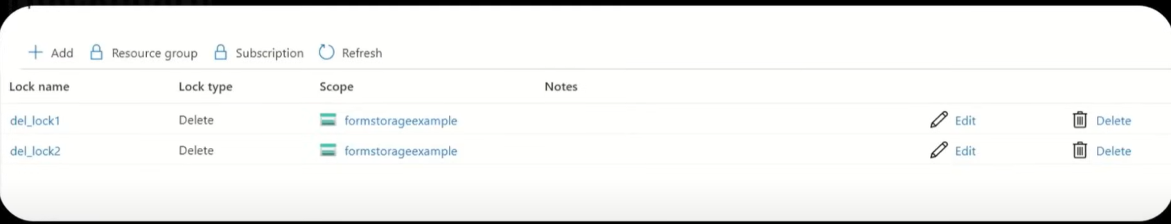

Q693. An Azure resource inherits locks from its resource group.

1. **Yes**
2. No

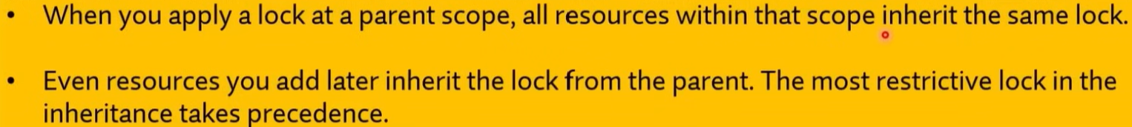

Q694. If an Azure resource has a read-only lock, you can add a delete lock to the resource.

1. **Yes**
2. No

Q695. Azure advisor provides recommendations on how to improve the security of an Azure Active Directory (Microsoft Entra ID) environment.

1. Yes
2. **No**

**Explanation**:  
**Azure Advisor** provides recommendations on best practices for optimizing performance, cost, reliability, and operational excellence for your Azure resources. However, it does not provide specific recommendations for improving the security of an **Azure Active Directory** (Microsoft Entra ID) environment. For security recommendations related to Azure Active Directory (Microsoft Entra ID), you would use **Azure Security Centre** or **Microsoft Entra** (formerly known as Azure AD Identity Protection).

Q696. Azure advisor provides recommendations on how to reduce the cost of running Azure VM’s.

1. **Yes**
2. No

Q697. Azure advisor provides recommendations on how to configure the network settings on Azure VM's.

1. Yes
2. **No**

Q698. You can configure the Azure Active Directory (Azure AD) (Microsoft Entra ID) activity logs to appear in Azure Monitor.

1. **Yes**
2. No

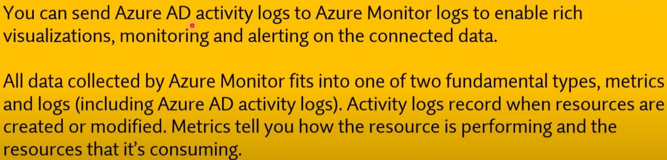

Q699. From Azure Monitor, you can monitor resources across multiple Azure subscriptions.

1. **Yes**
2. No



Q700. With Azure Monitor, you can create alerts.

1. **Yes**
2. No

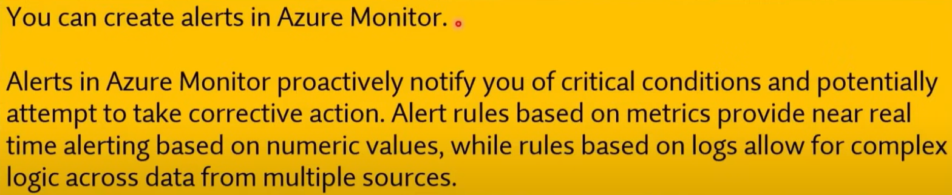

Q701. Microsoft Defender for cloud can monitor Azure resources and on-premises resources.

1. **Yes**
2. No

**Explanation**:  
**Microsoft Defender for Cloud** can monitor both **Azure resources** and **on-premises resources**. It provides security recommendations and threat detection across hybrid environments, helping secure your entire infrastructure, whether in the cloud or on-premises.

Q702. All features of Microsoft Defender for cloud are free.

1. Yes
2. **No**

**Explanation**:  
Not all features of **Microsoft Defender for Cloud** are free. Microsoft Defender for Cloud offers a **free tier** that provides basic security recommendations and monitoring. However, advanced features such as threat detection, vulnerability assessments, and advanced threat protection for specific services require the **paid tier** (Microsoft Defender plan).

Q703. For Microsoft Defender for cloud, you can download a Regulatory Compliance report.

1. **Yes**
2. No

* <https://www.microsoft.com/en/security/business/microsoft-defender>

**Explanation**:  
In **Microsoft Defender for Cloud**, you can download a **Regulatory Compliance** report. This feature allows you to assess how your Azure environment complies with various industry standards and regulations, such as ISO 27001, GDPR, and others. You can generate and download reports that provide insights into your compliance status and any necessary remediation actions.

Q704. Adding resource groups in an Azure subscription generates additional costs.

1. Yes
2. **No**



Q705. Storing 1 TB of data in Azure Blob storage will always cost the same, regardless of the Azure region in which the data is located.

1. Yes
2. **No**



Q706. When you use a general-purpose v2 Azure Storage account, you are only charged for the amount of data that is stored. All read and write operations are free.

1. Yes
2. **No**



Q707. Copying 10 GB of data to Azure from an on-premises network over a VPN generates additional Azure data transfer costs.

1. Yes
2. **No**



Q708. Copying 10 GB of data from Azure to an on-premises network over a VPN generates additional Azure data transfer costs.

1. **Yes**
2. No

Q709. Transferring data between Azure Storage accounts in different Azure regions is free.

1. Yes
2. **No**



Q710. In Azure Active Directory (Microsoft Entra ID) Premium P2, at least 99.9 percent availability is guaranteed.

1. **Yes**
2. No

Q711. The Service Level Agreement (SLA) for Azure Active Directory (Microsoft Entra ID) Premium P2 is the same as the SLA for Azure Active Directory (Microsoft Entra ID Free.

1. Yes
2. **No**

Q712. All paying Azure customers receive a credit if their monthly uptime percentage is below the guaranteed amount in the Service Level Agreement (SLA).

1. **Yes**
2. No

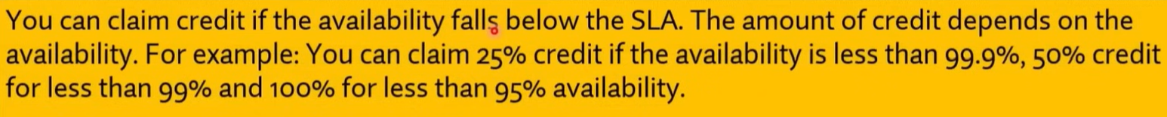

Q713. To answer, drag the appropriate benefit from the column on the left to its description on the right. Each benefit may be used once, more than once, or not at all.

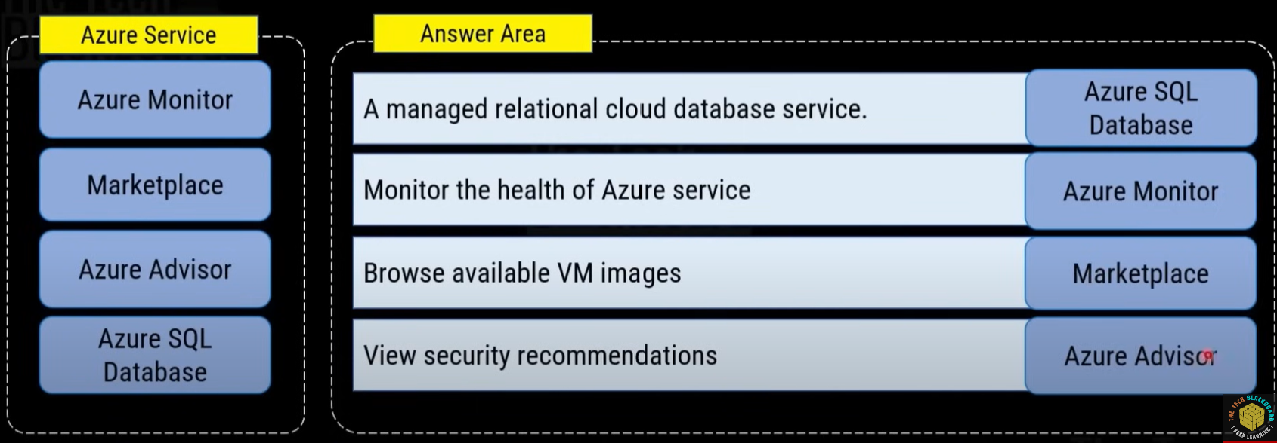

Q714. You have completed the migration of your organization's core servers and processes to cloud-based virtual machines.

Your final project involves migrating a weekly batch-processing task that relies on operating system drivers to print PDF reports. You need to meet this requirement while minimizing costs.

What should you do?

1. **Run the batch processing task using spot instances.**
2. Execute the batch task on a dedicated virtual machine as needed.
3. Configure virtual machine clusters to scale for batch processing.
4. Migrate the batch processing to serverless computer.

**Explanation**:  
**Spot instances** offer a cost-effective solution for running batch tasks that can handle interruptions. Since spot instances provide unused Azure capacity at a significant discount, they are ideal for tasks like batch processing that can be paused and resumed without affecting critical workloads. This would minimize costs while still allowing the batch task to run efficiently.

**Other Options**:

* **b. Execute the batch task on a dedicated virtual machine as needed**: This would work, but using dedicated virtual machines can be more expensive than spot instances.
* **c. Configure virtual machine clusters to scale for batch processing**: While this might be useful for scaling large workloads, it's not necessary for a simple weekly batch task and would likely increase costs.
* **d. Migrate the batch processing to serverless compute**: Serverless computing is typically better for event-driven tasks or stateless processes, but batch tasks requiring OS drivers for printing are not well-suited for serverless environments.

Q715. Your company deploys resources in Azure. According to the shared responsibility model, which task will you be required to perform?

1. Configure connectivity between regions.
2. Manage access to data center resources.
3. Upgrade RAM on virtualization systems.
4. **Install critical updates on virtual machines.**

**Explanation**:  
In the **shared responsibility model** for cloud services, Microsoft is responsible for managing the underlying infrastructure (e.g., data centers, physical servers, networking), while customers are responsible for managing the **operating system**, applications, and data on their virtual machines. This includes tasks like **installing critical updates** and **patching** the OS.

**Other Options**:

* **a. Configure connectivity between regions**: This is part of the customer's responsibility, but it involves networking rather than the VM management task in question.
* **b. Manage access to data centre resources**: Microsoft handles data center security and access.
* **c. Upgrade RAM on virtualization systems**: Microsoft manages the physical infrastructure, including virtualization systems.

Q716. ExpressRoute is at which OSI layer?

1. 2
2. **3**
3. 5
4. 7

* <https://learn.microsoft.com/en-us/azure/architecture/reference-architectures/hybrid-networking/expressroute>

For Q717, Q718, and Q719.

**Statement**: You work for a small company that hosts its own web server running Microsoft Internet Information Services (lS) and email server running Microsoft Exchange.

* As demand for the web server increases, you want to add a secondary web server to spread out the traffic.
* As demand decreases, you want to decommission the web server to save energy and maintenance. You consider moving the current infrastructure to the cloud.

You need to determine the benefits of moving the infrastructure to the cloud.

For each of the following statements, select Yes if the statement is true. Otherwise, select No.

Q717. You can use horizontal scaling for the web server.

1. **Yes**
2. No



Q718. You can resize the disk on demand on mail server if e-mail messages increase.

1. **Yes**
2. No



Q719. You eliminate the cost of having IT staff.

1. Yes
2. **No**



Q720. Which service lets you extend your on-premises networks into the Microsoft cloud over a private connection, with the help of a connectivity provider.

1. Azure Network
2. **ExpressRoute**
3. Azure VPN Network
4. Azure CDN

Q721. You have an accounting application named Appl that uses a legacy database. You plan to move Appl to the cloud. Which service model should you use?

1. platform as service (PaaS)
2. **infrastructure as a service (laaS)**
3. software as a service (SaaS)

**Explanation**:  
Since **Appl** is an existing application that uses a legacy database, **Infrastructure as a Service (IaaS)** is the best model for moving it to the cloud. IaaS allows you to migrate the application and its database with minimal changes, as you can create virtual machines that mimic your on-premises infrastructure. This model provides more control over the environment, including the ability to manage the legacy database.

**Other Options**:

* **a. Platform as a Service (PaaS)**: This would require rearchitecting the legacy application to fit the platform's model, which may not be ideal for legacy systems.
* **c. Software as a Service (SaaS)**: SaaS is for fully managed applications, and it would not support your custom legacy application unless you replace it entirely with a new software solution.

Q722. What is the longest term you can purchase for Azure Reserved VM Instances?

1. **Three years**
2. Four years
3. Five years
4. Ten years

Q723. Your company plans to deploy an Artificial Intelligence (Al) solution in Azure.

What should the company use to build, test, and deploy predictive analytics solutions?

1. Azure Logic Apps
2. **Azure Machine Learning designer**
3. Azure Batch
4. Azure Cosmos DB

* <https://learn.microsoft.com/en-us/azure/machine-learning/concept-designer?view=azureml-api-2>

Q724. This question requires that you evaluate the underlined text to determine if it is correct.

Azure policies provide a common platform for deploying objects to a cloud infrastructure and for implementing consistency across the Azure environment.

Instructions: Review the underlined text. If it makes the statement correct, select "No change is needed". the statement is incorrect, select the answer choice that makes the statement correct.

1. No change is needed
2. Resource groups
3. **Azure Resource Manager**
4. Management groups

* <https://learn.microsoft.com/en-us/azure/azure-resource-manager/management/overview>

**Explanation**:  
**Azure Resource Manager (ARM)** provides a common platform for deploying objects to a cloud infrastructure and for implementing consistency across the Azure environment. ARM allows you to manage and deploy resources in Azure using templates and ensures that deployments are done in a consistent manner.

* **Azure policies** are used to enforce rules and ensure compliance across Azure resources, but they are not the platform for deploying resources.
* **Resource groups** are logical containers for managing resources but are not responsible for deployment.
* **Management groups** help organize and manage multiple subscriptions, but they don't handle resource deployment.

Q725. Your company has several business units. Each business unit requires 20 different Azure resources for daily operation. All the business units require the same type of Azure resources. You need to recommend a solution to automate the creation of the Azure resources.

What should you include in the recommendations?

1. **Azure Resource Manager templates**
2. Virtual machine scale sets
3. Azure API Management service
4. Management groups

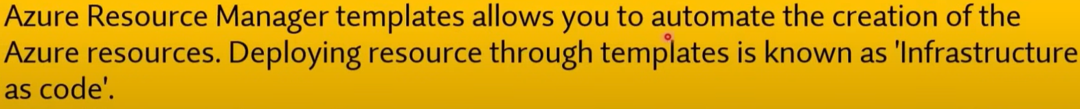

Q726. Which resources can be used as a source for a Network security group inbound security rule?

1. Service Tags only
2. **IP Addresses, Service tags and Application security groups**
3. Application security groups only
4. IP Addresses only

* Classless Inter-Domain Routing (CIDR)

Q727. Azure Active Directory (Azure AD) (Microsoft Entra ID) is used to manage API cryptographic keys.

1. Yes
2. **No**

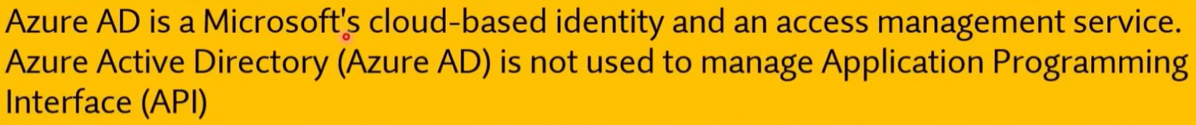

Q728. Azure Storage encryption is enabled by default and cannot be disabled.

1. **Yes**
2. No

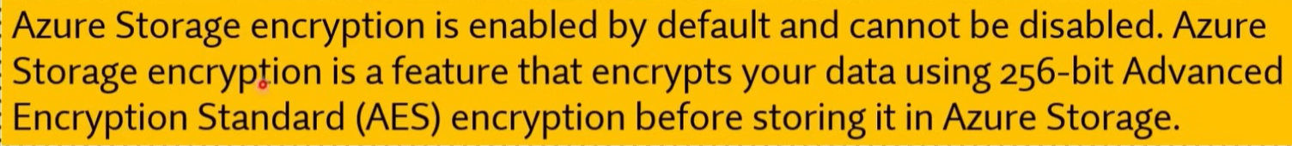

Q729. To answer, drag the appropriate benefit from the column on the left to its description on the right. Each benefit may be used once, more than once, or not at all.

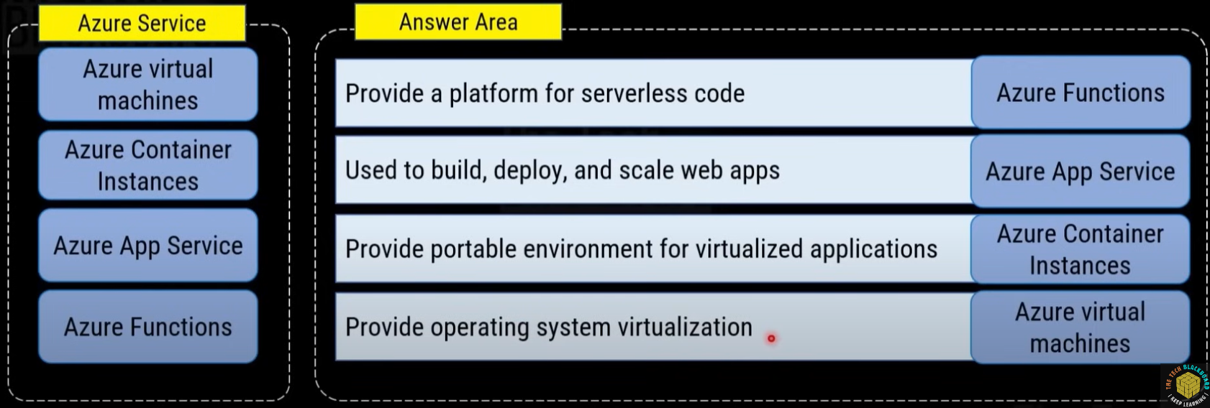

Q730. Azure ExpressRoute is used to secure traffic between virtual networks.

1. Yes
2. **No**

* <https://learn.microsoft.com/en-us/azure/expressroute/expressroute-faqs>

Q731. ExpressRoute is an Azure service that lets you create private connections between Microsoft datacenters and infrastructure that's on your premises or in a colocation facility.

1. **Yes**
2. No

Q732. ExpressRoute connections go over the public Internet.

1. Yes
2. **No**

Q733. Can you use the same private network connection with virtual network and other Azure services simultaneously?

1. **Yes**
2. No

Q734. The point-to-site VPN connection enables you to set up a private and secure connection between the user and the virtual network.

1. **Yes**
2. No

Q735. Azure Blob Storage is a

1. data store for queuing and reliably delivering messages between applications. (Azure Queue Storage)
2. File share that can be mapped as a network drive. (Azure Files Storage)
3. Key/Attribute store for non-relational, structured data. (Azure Tables Storage)
4. **storage service optimized for very large objects, such as video files and bitmaps.**

* <https://learn.microsoft.com/en-us/azure/storage/common/storage-introduction>

Q736. Which statements regarding Cosmos DB are correct? (Choose Two)

1. **API selection determines the account type**
2. Relationships can be defined
3. A structured schema is used
4. **Encryption for data at rest is enabled by default**

* <https://learn.microsoft.com/en-us/azure/cosmos-db/introduction>

**Explanation**:

* **API selection determines the account type**: Cosmos DB supports multiple APIs (such as SQL, MongoDB, Cassandra, Gremlin, and Table APIs), and the choice of API determines the type of account and how data is accessed.
* **Encryption for data at rest is enabled by default**: Cosmos DB automatically encrypts all data at rest, ensuring the security of stored data without additional configuration.

**Other Options**:

* **b. Relationships can be defined**: Cosmos DB is a NoSQL database, and while some APIs (like Gremlin) support graph structures, traditional relationships (as in relational databases) are not a native feature.
* **c. A structured schema is used**: Cosmos DB is schema-agnostic, meaning that it does not require a structured schema and allows for flexible data models.

Q737. Which service below is Microsoft's managed network security service in Azure that protects Azure Virtual Network resources?

1. Azure VNET
2. Azure Firewall
3. **Network Security Group**
4. Application Security Group

Q738. Content Delivery Network (CDN) allows you to reduce the traffic coming into a web server for static, unchanging files such as images, videos, and PDFs.

1. **Yes**
2. No

* <https://learn.microsoft.com/en-us/azure/cdn/cdn-overview>

Q739. Azure Active Directory (Microsoft Entra ID) is a network gateway that load balances user logins using a CDN (Content Delivery Network).

1. Yes
2. **No**

Q740. The Azure App Service is an HTTP-based service for hosting web applications, REST APIs, and mobile back ends.

1. **Yes**
2. No

Q741. Which services are part of Azure Storage Account service?

1. **Azure Table Storage**
2. **Azure File Storage**
3. Azure Hard drive
4. **Azure Queue Storage**
5. Azure Disk Storage
6. **Azure Blog Storage**

* <https://learn.microsoft.com/en-us/azure/storage/common/storage-introduction>

Q742. Which node in the Azure portal should you use to assign a user the Reader role for a resource group?

To answer, select the node in the answer area.

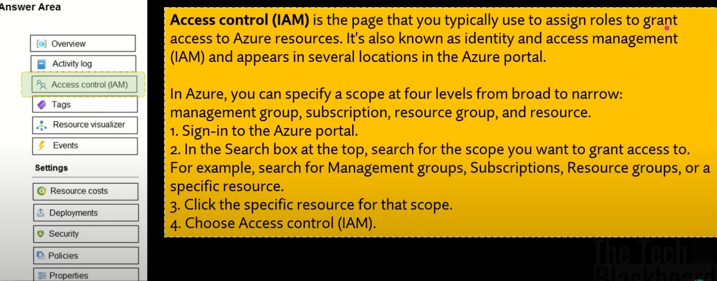

Q743. Three keys available in the properties blade for Azure Cognitive services?

1. Yes
2. **No**

**Explanation**:  
In the **Azure Cognitive Services** properties blade, typically only **two keys** are available. These keys are used for authentication when accessing the Cognitive Services APIs. There are not three keys provided; the two keys allow for key rotation without causing disruption to your services.

Q744. You can use Network Security Group to configure network security as an extension of an application's structure.

1. Yes
2. **No**

* Application Security Group

Q745. The Microsoft Sentinel service is a scalable, cloud-native, Security information and event management (SIEM) and Security orchestration, automation, and response (SOAR).

1. **Yes**
2. No

* <https://learn.microsoft.com/en-us/azure/sentinel/overview?tabs=azure-portal>

Q746. Why are two keys available in the properties blade for Azure Cognitive services?

1. Keys for Windows and Linux platforms
2. **Key safekeeping**
3. Period key regeneration for security
4. Enhanced performance

Q747. A Microsoft SQL Server database that is hosted in the cloud Virtual Machine is an example of:

1. **Infrastructure as a Service (laaS)**
2. Platform as a service (PaaS)
3. Software as a service (SaaS)

Q748. Which storage service below is best for serving images or documents directly to a browser, and for streaming video and audio?

1. **Azure Blob Storage**
2. Azure File Storage
3. Virtual Machine Disks
4. Queue Storage

Q749. A Microsoft SQL Server database that is hosted in the cloud and has software updates managed by Azure is an example of:

1. Infrastructure as a Service (laaS)
2. **Platform as a service (PaaS)**
3. Software as a service (SaaS)

Q750. You need to collect and automatically analyze security events from Azure Active Directory (Azure AD) (Microsoft Entra ID). What should you use?

1. Azure Synapse Analytics
2. Azure AD (Microsoft Entra ID) Connect
3. Azure Key Vault
4. **Azure Sentinel**

Q751. Which Azure automatic tool can Monitor all services and rapidly respond to threats?

1. Microsoft Authenticator
2. **Microsoft Defender for Cloud**
3. Multi Factor Authentication
4. Azure Firewall

Q752. Microsoft Defender for Cloud is a cloud-native application protection platform (CNAPP) with a set of security measures and practices designed to protect cloud-based applications from various cyber threats and vulnerabilities.

1. **Yes**
2. No

* <https://learn.microsoft.com/en-us/azure/defender-for-cloud/defender-for-cloud-introduction>

Q753. Which service enables you to achieve those goals is the secure score.

1. Microsoft Authenticator
2. **Microsoft Defender for Cloud**
3. Multi Factor Authentication
4. Azure score board

* <https://learn.microsoft.com/en-us/azure/defender-for-cloud/secure-score-security-controls>

Q754. Defender for Cloud continually assesses your cross-cloud resources for security issues.

1. **Yes**
2. No

Q755. Which Azure service is cloud-native and intelligent network firewall security service that provides threat protection for your cloud workloads running in Azure?

1. Microsoft Authenticator
2. Microsoft Defender for Cloud
3. Multi Factor Authentication
4. **Azure Firewall**

* <https://learn.microsoft.com/en-us/azure/firewall/overview>

**Explanation**:  
**Azure Firewall** is a cloud-native, intelligent network firewall security service that provides threat protection for your Azure cloud workloads. It offers features such as threat intelligence, network filtering, and application-level filtering to protect Azure resources from potential security threats.

**Other Options**:

* **a. Microsoft Authenticator**: This is a multi-factor authentication app, not a firewall security service.
* **b. Microsoft Defender for Cloud**: This is a broader security service for monitoring and securing Azure resources but not specifically a network firewall.
* **c. Multi-Factor Authentication**: This provides additional authentication security, not network threat protection.

Q756. Which Azure service is a managed, cloud-based network security service that protects your Azure Virtual Network resources?

1. Microsoft Authenticator
2. Microsoft Defender for Cloud
3. Multi Factor Authentication
4. **Azure Firewall**

Q757. Azure firewall is fully stateful.

1. **Yes**
2. No

It's a fully stateful firewall as a service with built-in high availability and unrestricted cloud scalability.

Q758. Azure firewall is scalable.

1. **Yes**
2. No

Q759. By default, all traffic through the firewall is blocked, a rule must be added in order to enable traffic flow.

1. **Yes**
2. No



Q760. You have an Azure environment that contains 10 virtual networks and 100 virtual machines. You need to limit the amount of inbound traffic to all the Azure virtual networks. What should you create?

1. one application security group (ASG)
2. 10 virtual network gateways
3. 10 Azure ExpressRoute circuits
4. **one Azure firewall**

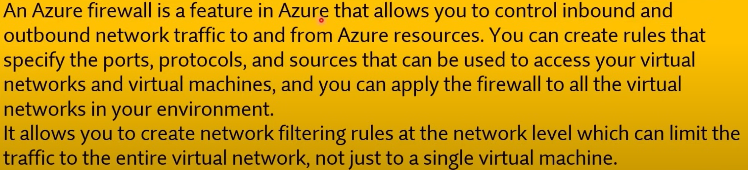

Q761. If you need basic network level access control (based on IP address and the TCP or UDP protocols), which service should you use?

1. Microsoft Defender
2. Application security group (ASG)
3. **Network security group (NSG)**
4. Azure Firewall

* <https://learn.microsoft.com/en-us/azure/virtual-network/network-security-groups-overview>

**Explanation**:  
**Network Security Group (NSG)** provides basic network-level access control by allowing or denying traffic based on **IP addresses** and **TCP or UDP protocols**. It acts as a virtual firewall for controlling inbound and outbound traffic to Azure resources, such as virtual machines.

**Other Options**:

* **a. Microsoft Defender**: This provides broader security and threat detection but is not used specifically for network-level access control.
* **b. Application Security Group (ASG)**: ASG allows you to group virtual machines for simplified management of NSG rules, but it does not provide access control by itself.
* **d. Azure Firewall**: This provides more advanced and intelligent network protection, but for basic IP-based access control, NSG is more appropriate.

Q762. Which service can you use for Cloud's just-in-time (JIT) access to protect your Azure virtual machines (VMS) from unauthorized network access?

1. Application security group (ASG)
2. Network security group (NSG)
3. Azure Firewall
4. **Microsoft Defender**

Q763. Cross-Origin Resource Sharing (CORS) is a mechanism that allows domains to give each other permission for accessing each other's resources.

1. **Yes**
2. No

* <https://learn.microsoft.com/en-us/rest/api/storageservices/cross-origin-resource-sharing--cors--support-for-the-azure-storage-services>

Q764. Which Azure service allows you to store application secrets in a centralized cloud Iotation, to securely control access permissions, and access logging?

1. Azure Firewall
2. **Azure key vault**
3. Microsoft Defender

* <https://learn.microsoft.com/en-us/azure/key-vault/general/overview>

Q765. Which service provides a user-friendly Multi-Factor Authentication experience that works with both Microsoft Azure Active Directory (Microsoft Entra ID) and Microsoft accounts and includes support for wearables and fingerprint-based approvals.

1. Azure Firewall
2. Azure key vault
3. Microsoft Defender
4. **Microsoft Authenticator**

**Azure Virtual Training Day: Fundamentals Part 1**

1. Network Security Group = Lower index means higher priority.

